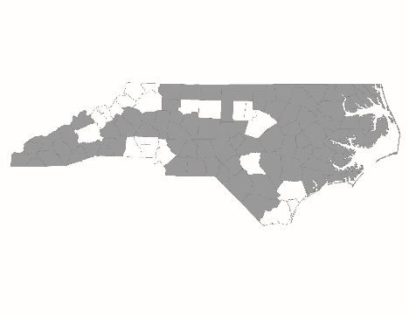

2018 NC Balance of State CoC Application
New Project Standards Form

New project applications are required to complete and submit this form to NCCEH by 6:00 p.m. on Thursday, August 9. Information provided will be used by the Project Review Committee and NCCEH staff to score and rank new project applications.

Project Information
Applicant Agency:

Project Name:

Project Type (RRH, PSH, SSO-CE):

General Application
Agency mission statement:
Please describe any prior or current experience that the agency has serving homeless households in your community:

Organizational Capacity
Has the agency successfully implemented a CoC-funded project of the same project type (PSH, RRH, or SSO-CE)? | Yes  No
If not, has the agency successfully implemented this same type of project (permanent supportive housing, rapid re-housing, or coordinated entry) using another funding source? | Yes  No  N/A
If the answer to either above question is yes, are the same staff that were operating the program at that time going to be operating the proposed project? | Yes  No  N/A
If none of the above, has the agency successfully implemented a different HUD-funded project (ESG, Section 8, HPRP, etc.) or a CoC-funded project of a different type? | Yes  No  N/A
Existing CoC Grantees:
If the agency has other existing projects, are there any HUD monitoring findings currently associated with any of these projects? | Yes  No
If yes, please explain what the findings were and if they have been resolved:

Number of grant extensions from HUD that were given for a reason other than merging grants:

Community Need Statement
New CoC projects must demonstrate that they are meeting an existing need in their community. Projects must describe below:
- What community need the new project will address
- Local data (PIT Count, coordinated assessment data, wait lists, etc.) that demonstrates this need
- How the community has used other resources to address this need

Targeting to Prioritized Subpopulations
HUD and the NC BoS CoC prioritize funding for certain homeless subpopulations, including chronically homeless individuals and families, homeless Veterans, people with disabilities, and youth. Please provide a narrative identifying the subpopulations that the project will serve and describing the ways in which the project will engage these subpopulations to ensure entry into permanent housing.

Describe the project’s plan to prioritize households with the longest histories of homelessness:

Describe the project’s plan to quickly enroll households experiencing homelessness and help them to find safe and appropriate housing, ideally within 30 days:

Coordinated Assessment
Describe the region’s coordinated assessment process, including the general process and how agencies with open housing slots get referrals from the local system. Please be detailed in your answer.

