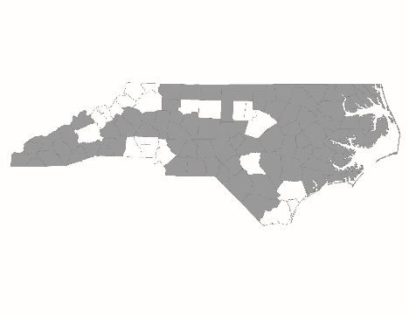

2018 NC Balance of State CoC Application
New Project Thresholds Form

New project applications are required to complete and submit this form to NCCEH by 6:00 p.m. on Thursday, July 26. Information provided will be used by the Project Review Committee and NCCEH staff to score and rank new project applications.

Project Information
Applicant Agency:

Project Name:

Project Type (RRH, PSH, SSO-CE):

PSH: Prioritization
For PSH projects: Is the project dedicated to serving chronically homeless households per HUD Notice CPD-16-11? | Yes  No

RRH: Prior Experience with HUD Funding
For RRH projects: Are you currently receiving ESG funds for RRH? | Yes  No
If yes, are you in good standing with the ESG office? | Yes  No
If no, are you currently operating a RRH program with other funding sources that adhere to RRH program standards as outlined in the New Project Scorecard? | Yes  No
If you are using other funding to operate a RRH program, what funding source(s) is the agency using?

Organizational Capacity
Has the agency been in operation for at least 3 years? | Yes  No

Project Performance
Does the agency commit to enter 100% of the beds into HMIS (with client consent)? | Yes  No
If the agency is a domestic violence service provider, does the agency have a comparable database that collects Universal Data Elements and can run required reports comparable to those from an HMIS? | Yes  No

Agency’s Relationship to Community
Does the agency agree to participate in the local coordinated assessment process as designed by your Regional Committee(s) and only take referrals directly from the coordinated entry prioritization wait list? | Yes  No
Has the agency presented the proposed project to the Regional Committee (either in person or electronically) and given the opportunity for feedback?

Date presented to Regional Committee:

And feedback received:

