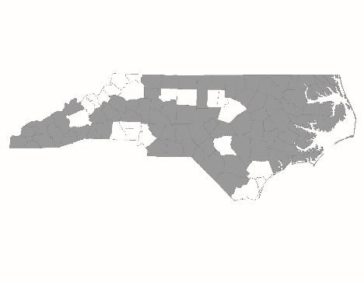

NC BoS CoC Steering Committee Workgroup Meeting
November 9, 2017
Workgroup attendance: Melissa McKeown, LaTasha McNair, Monica Frizzell, Jim Cox
NCCEH staff attendance: Ehren Dohler, Brian Alexander

Minutes
- Ehren provided an overview of efforts to recruit at-large members so far:
  - Both members with lived experience have accepted: Derrick Burnell and Barry Shipp
    - The workgroup plans to invite Barry Shipp to NC BoS CoC Regional Committee meetings to help him learn more about the NC BoS CoC. Ehren will invite Barry to the Region 5 meeting on December 13 in Stanly County. Melissa can help with transportation. Brian will be at that meeting. Melissa will check if Derrick can also come to that meeting.
  - Jessa Johnson who covers PSH in the DHHS office of the Secretary has accepted an at-large seat.
  - Lisa Phillips, the state-wide coordinator of McKinney-Vento Homeless School Liaisons has accepted an at-large seat.
  - Paul Kimball at the NC HFA has been offered a seat. He was very interested but needed to check whether he has the time to commit. Ehren will check with him to see whether he or someone else from NC HFA will be able to hold the at-large seat.
  - Ehren suggested adding a member of the Coordinated Assessment Council to the Steering Committee. They would bring experience with CA, and many of them are very committed to the NC BoS CoC’s work. Ehren suggested either Stephanie Williams or Angela Harper King. They both work for NC DHHS. Stephanie works on the TCLI program. Angela Harper King oversees mental health services and MCOs. The workgroup agreed this was a good idea. Ehren will reach out to them to see who would be the best fit and have the time for the commitment.
  - Jim connected with the president of the state-wide DSS Director’s Association – Donna Fayko. He had a brief conversation with her, and she expressed interest and wanted to learn more. Ehren is trying to get ahold of her but has not talked to her yet.
- Monica has been trying to get ahold of Parker Smith at Pisgah Legal but has not talked to her yet.
- Jim is talking to his connections in the NC Office of rural health. They are exploring some options.
- LaTasha talk to Felica Flower, the NC Council for Women Eastern Region Director. She expressed interest. Felica is new to her position – LaTasha had a very good relationship with the previous Eastern Region Director but does not know Felica very well. The NC Council for Women is the main funder for DV agencies in the state. They do have a youth component – SADD – Students Against Destructive Decisions, but that is not part of Felica’s role.
  - Ehren suggested that there would be both advantages and drawbacks to having the main DV funder on the Steering Committee. They would need to be able to see their role on the Steering Committee as different than their role as a monitoring agency. The NC BoS CoC’s DV agencies may have problems with the NC Council for Women joining the Steering Committee. Ehren asked what the workgroup thought about this.
  - Brian mentioned that having someone from the NC Council on Women would have some advantages: they could align policies with the CoC and help bring more DV agencies on board, since they control the funding. Would these advantages outweigh the potential difficulties of this relationships?
  - The workgroup will talk to DV agencies in their area to see what they think.
- LaTasha also talked to the director of patient services at Vidant Duplin. LaTasha asked whether there is someone else in Vidant who might be a better fit and hasn’t heard back.
- Jim asked whether we might want someone from academia. Ehren suggested we could ask Emily Carmody if there are any partners in her research project who might be good and would fill the health sector at-large seat.
- The next meeting will be the last week of November.

