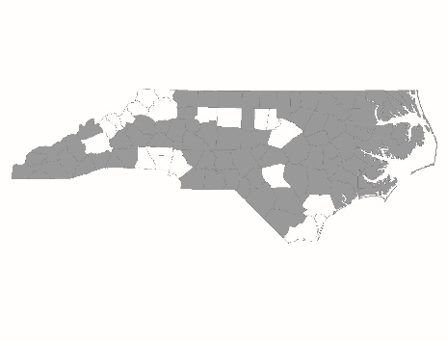
Rapid Re-Housing Form

Applicants must complete this form with information about their Rapid Re-Housing (RRH) program. If an applicant is applying for funding for more than one RRH program, they must complete a separate form for each program. Incomplete forms will not meet standards and/or receive the lowest possible score on the scorecard.
The answers to the following questions will be used by the Project Review Committee and NCCEH staff to score questions on the scorecard that refer to the RRH program’s policies, procedures, and program design.
Applicant:
Project Name:

Rapid Re-Housing Program Standards

Housing Identification
Does the program have dedicated staff whose responsibility is to identify and recruit landlords and encourage them to rent to homeless households served by the program? | Yes  No
If no, do the case manager’s responsibilities include landlord recruitment and negotiation? | Yes  No
Is staff trained in landlord recruitment? | Yes  No
If yes, please describe:
Does your program offer a standard, basic level of support to all landlords? | Yes  No
If yes, please describe:

Rent and Move-In Assistance
Are program staff trained on regulatory requirements of all rapid re-housing funding streams and on the ethical use and application of a program’s financial assistance policies, including, but not limited to, initial and ongoing eligibility criteria, program requirements, and assistance maximums? | Yes  No
If yes, please describe:
Does the program use a progressive approach, where financial assistance is not a standard “package” and is flexible enough to adjust to households’ unique needs and resources, for determining the duration and amount of rental assistance provided? | Yes  No
If yes, please describe:

Case Management and Services
Do program participants direct when, where, and how often case management meetings occur? (The intent of this standard is that program participants are involved in creating a mutually agreed-upon time, place, and frequency of meetings with the case manager.) | Yes  No
Do meetings occur in a participant’s home and/or in a location of the participant’s choosing whenever possible? (The intent of this standard is that program participants are involved in creating a mutually agreed-upon time, place, and frequency of meetings with the case manager.) | Yes  No
Is participation in services voluntary? | Yes  No
Do you have a relationship with employment and income programs to which to refer RRH participants? | Yes  No
If yes, please describe:

Philosophy and Design:
Is program staff trained on the principles of Housing First? | Yes  No
If yes, please describe:
Is program staff oriented to the basic program philosophy of rapid re-housing? | Yes  No
If yes, please describe:
Does your program require participants have income? | Yes  No
Does your program require participants be sober? | Yes  No
Does your program require a commitment to participate in treatment? | Yes  No
If other eligibility requirements exist, please describe:

Documentation

Please attach and submit the following documentation from the RRH program. (Agencies applying for new RRH projects should submit the documentation from their existing RRH program.)

RRH program eligibility criteria
Sample lease
Written policies/procedures for landlord recruitment activities
Written policy requiring staff to participants basic landlord-tenant rights and responsibilities/requirements of their lease
Written policies/procedures for determining amount of financial assistance and when case management/financial assistance should continue and end
Written screening processes for participants

Page References
The following chart lists program design elements that are scored based on the documentation submitted by the agency (from the list above). For each element in the chart, please list the name of the document(s) and the page number(s) on which the item appears.

Scorecard question #* | Program Design Element | Document Name | Page Number(s)
2.2a & 2.7d2 R  2.14a & 2.16d2 N | Participant screening procedure
2.2b R  2.14b N | Participant termination procedure
2.7a2 R  2.16a2 N | Procedures for landlord recruitment
2.7a3 R  2.16a3 N | Policy for landlord support
2.7a4 R  2.16a4 N | Policy for explaining landlord-tenant rights & lease requirements
2.7b2 & 2.7b3 R  2.16b2 & 2.16b3 N | Procedure for determining amount & duration of assistance
2.7c1 R  2.16c1 N | Procedures for determining frequency & location of case mtg. meetings
2.7c2 R  2.16c2 N | Voluntary services
2.7c3 R  2.16c3 N | Relationships with employment & income programs
2.7c4 R  2.16c4 N | Policy for when case mgt. continues and ends
2.7d3 R  2.16d3 N | Participant eligibility criteria

*R = Renewal scorecard
*N = New scorecard

