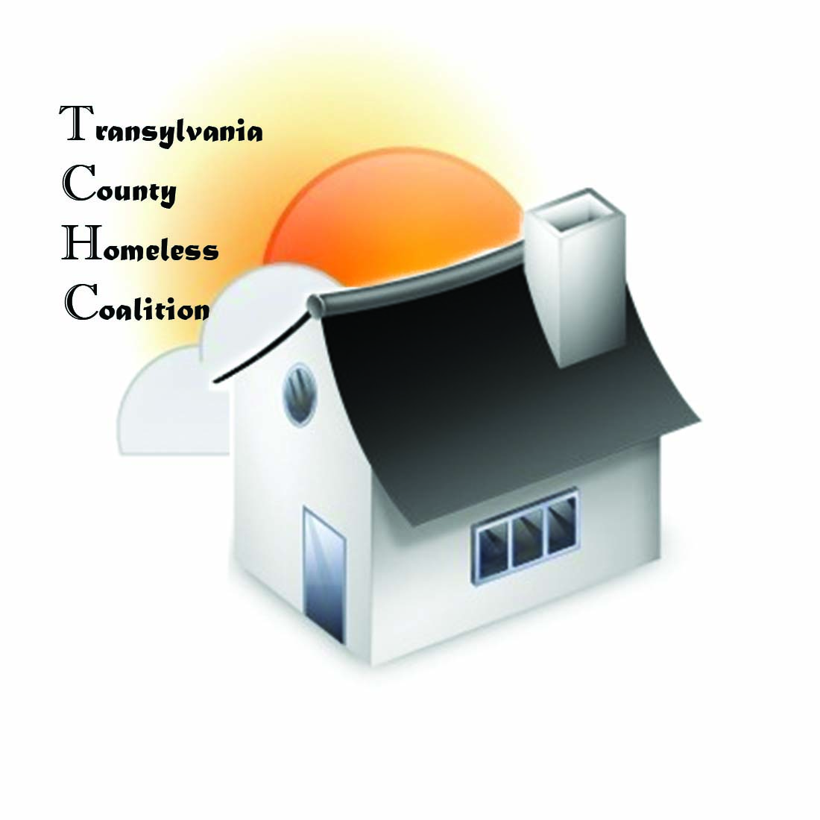
Transylvania County Homeless Coalition
Meeting Minutes

Location: Brevard Housing Authority
133 W. Morgan Street
Brevard, NC 28712
Date: January 7, 2016

Attendees:
Jennifer Molliere, Haven Barbara Marr, TRAIN
Beth Branagan, TCS Shelly Miller, TCS Terry Decker, United Way Drew Brennan, Meridian Amy Upham, Smoky Mountain Ellen Sizemore, Meridian
Emily Lowery, Haven David Carr, VSC/SSVF
Ariana DeToro-Forlenza, VA Homeless Prog. Don Rogers, United Way
Rhodney Norman, Brevard Housing Authority Heather Bradley, Health Department
Marla Browne, NC211 Emily Lowery, Haven

- Meeting called to order 9:05 am
- Minutes Approved
- Agency Updates
  - Haven-
    - Haven Family House – Waiting list, 10 families, 1 room was offline and is online again
    - Haven – New Assistant Director hired, Mark Fields, will be working directly with residents in the evening weekdays
    - Haven – have vacant beds
    - ESG – housed 4 families
  - Meridian – New program, Community Support Team, has a team leader and is accepting reffereals for this program. It is Medicaid funded for mental health. Referral is made and then an assessment is done through R. E. C., then C. S. T. (Community Support Team). Crisis Line available.
    - Opening up children’s services (Shannon Ford), therapeutic care for foster care – traning provided
  - Transylvania County Schools – 75-80 children are homeless in this county.
    - They are planning ahead for upcoming weather on chrombooks have already been sent home
  - Veteran Services Council will meet in the meeting room at library the 15th at 10 am.
- Health Department – is working on the state of the child report
- United Way – housing trust fund – looking to build small houses
  - Transportation – public-hitch-a-ride, but ap does not work properly
- Bread of Life – Lee McMinn is the new President, Steve Martin, Vice President
- ABCCM – looking for a trailer to rent
  - This program supports those that are homeless or evicted
  - 90 day program and modeled as housing first logic
  - Serves 7 counties serving 26
  - Must have DD214 or ID – no dishonorable discharge
- TRAIN – goals the help strengthen exisisting coalition
  - Veterans Services Council – meets 15th at library at 10 am
  - Tolerance and Diversity – meeting at Hospital Newland Confereance Room 5:45
  - Roundtable Meeting – 21st at 8:30 am at Community Services Buildling
  - C. A.R. E. Coalition is hoping to keep youth group going and looking for a facilitator
  - Christmas Blessings – press realease is coming soon with total number served
  - Charity Tracker – Gas Voucher Referrals, limited funds through The Haven
  - County Commisioners Jan. 27th 12 -2 (lunch served) in Laughter Chambers
- Coordinated Assessment – done, and was rejected, again. Need to re-submit
- ESG – Contracts are coming by end of month
- PIT – Thursday the 28th is count. Volunteers needed. Count will ask where that person slept on the night before.
  - Will have goody bags and snacks
  - 30th is God’s Way Event – blanket drive and agency outreach to Balsam Grove
    - Sharing House and Anchor Baptist have been collecting items for this event, need volunteers to help sort
- God’s Way Event – resource fair with agency representation to outreach to Balsam Grove

Meeting Adjourned at 10:10
Next Meeting Scheduled for February 4, 2016

Meeting Adjourned at 9:40 am

