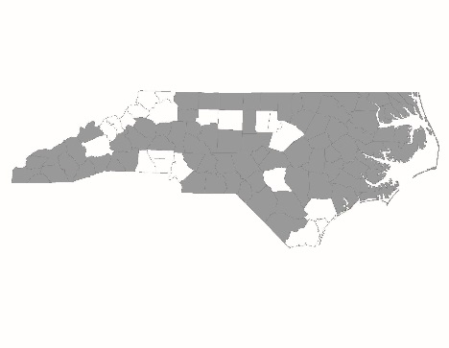

CONTINUUM OF CARE GRANTEE CERTIFICATION

Background: The North Carolina Coalition to End Homelessness (NCCEH) serves as the collaborative applicant for the NC Balance of State Continuum of Care (CoC) and as such is charged by HUD to operate and administer CoC activities and to monitor grantee performance (24 CFR Part 578). To further CoC goals and to clarify expectations, NCCEH is setting out grant recipient responsibilities in this document to be signed by an authorized representative of the grant recipient agency.

CoC grant recipients have a grant agreement with the U.S. Department of Housing and Urban Development (HUD). The grant recipient is responsible for adhering to all requirements and obligations outlined by HUD. In the event that grant recipient responsibilities change, revisions will be made to this certification and will require a new signature.

Before applying for renewal or new CoC funding, it is imperative that all project applicants read the CoC Program Interim Rule (24 CFR Part 578) as it provides the requirements for implementation and administration of the CoC Program.

Agency:
Contact Person:
Regional Committees covered by grant activities:

I have read and understand the expectations set forth in this certification.

______________________________________________ ________________________________
Signature Date

______________________________________________ ________________________________
Printed Name Title

HMIS Participation and Coverage
CoC grant recipients must collect the following information on the persons served and services provided during the grant period and enter this information into NC Homeless Management Information System (HMIS). Domestic violence service providers are prohibited from participation in HMIS, but must demonstrate that they have a database comparable to an HMIS and are able to provide statistical information from that database upon request that does not compromise client privacy.

Universal Data Elements Program Specific Data Elements
Name Housing Status
Social Security Number Income & Sources of Income
Date of Birth Non-Cash Benefits
Race Health Insurance
Ethnicity Physical Disability
Gender Developmental Disability
Veteran Status Chronic Health Condition
Disabling Condition HIV/AIDS
Residence Prior to Project Entry Mental Health Problem
Project Entry Date Substance Abuse
Project Exit Date Domestic Violence
Destination at Project Exit Residential Move-In Date (Rapid Rehousing)
Personal ID Services Provided (Rapid Rehousing)
Household ID Financial Assistance Provided (Rapid Rehousing)
Relationship to the Head of Household
Client Location
Length of Time on Street or in Emerg. Shelter

Project Parameters
- Permanent supportive housing projects will follow HUD guidelines for targeting and prioritizing PSH units for chronically homeless participants (HUD Notice CPD-14-012) and will follow the Balance of State Chronically Homeless Prioritization policy.
- Permanent supportive housing projects will adopt the key elements of permanent supportive housing as defined by the Substance Abuse and Mental Health Services Administration (SAMHSA)

Grant Performance & Reports
- All grant recipients will receive approval from the Balance of State CoC prior to requesting a grant extension from HUD
- All grant recipients will report grant spending to Balance of State CoC staff on a quarterly basis by submitting their project spending report screen shot from eLOCCS
- All grant recipients will submit quarterly Balance of State Performance Improvement Process (PIP) reporting once this process is established
- All grant recipients will submit Point-in-Time Count and Housing Inventory Count data by deadlines established by NCCEH and local Regional Committees
- All grant recipients will submit APRs to NCCEH for review prior to HUD submission
- All grant recipients will submit APRs to HUD on or before report deadline
- In the event that a grant recipient can no longer administer their grant, the grant recipient will consult the Balance of State CoC prior to transferring the grant to a different agency

Regional Committee Activities
- All grant recipients will participate in at least 75% of Regional Committee meetings in a 12-month period
- All grant recipients will participate in BoS Subcommittees pertaining to their grant types (PSH Subcommittee for permanent supportive housing grantees, RRH Subcommittee for rapid re-housing grantees)
- All project applicants will present their CoC project application(s) to the Regional Committee for local review prior to submission to NCCEH by the project application deadline
- All grant recipients will participate in the ESG application process in every Regional Committee covered by grant activities
- All grant recipients will present updates on grant activities to the Regional Committee(s) covered by the grant on at least a quarterly basis
- All grant recipients will participate in the local coordinated assessment process as designed by the Regional Committee(s)
- Grant recipients are expected to support Regional Committee(s) covered by grant activities as they achieve the following standards:
  - Meet minimum standards of BoS Regional Committees
    - Hold regular meetings
    - Implement coordinated assessment
    - Post meeting minutes to NCCEH website within 30 days of meeting date
  - Regional Lead, alternate or other designated member of the Regional Committee participates in at least 80% of Steering Committee meetings

US Department of Health and Human Services, Substance Abuse and Mental Health Services Administration Center for Mental Health Services. (2010) Permanent Supportive Housing: Building Your Program (Evidence- Based Practices KIT). Retrieved from http://store.samhsa.gov/shin/content//SMA10-4510/SMA10-4510-06-BuildingYourProgram-PSH.pdf

