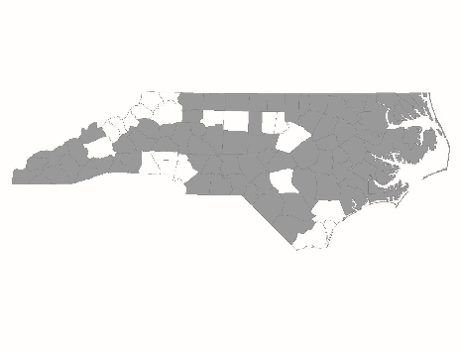

New Applicant
Permanent Supportive Housing
Policies and Procedures Page Reference Form

Applicant:
Project Name:

Page References
The following chart lists program design and other elements that the CoC scores based on documentation submitted by the agency. For each element in the chart, please list the policies and procedures’ page number(s) on which the item appears. If the element does not appear in the program’s policies and procedures, mark the cell as N/A.

Scorecard Question Number | Program Design Element | Page Number(s)
2.2c | HUD Notice CPD 16-011
2.4b | Eligibility requirements
2.4c | Reasons for termination
2.5b | Participation in services
2.5c | Participation agreement/house rules
2.5d | Housing limits
2.5e | Service choice
2.5f | Service duration/intensity
2.5g | Housing choice
2.5h | Housing-focused services
2.5i | Distinction of housing vs. services

