Child Bedroom Kit Order Form
Complete 1 Per Bedroom
Head of Household Name: ______
Number of Children in Bedroom: ______

Bedframe
Quantity: ______
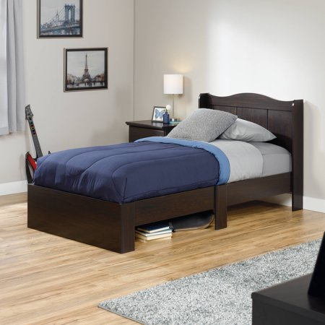  Dark Brown | 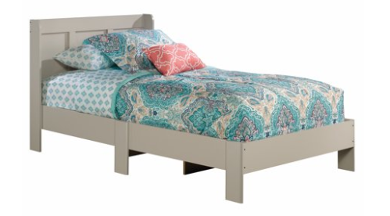  Light Gray

Twin Mattress
Mattress Needed? Yes No
Quantity: ______

Lamp
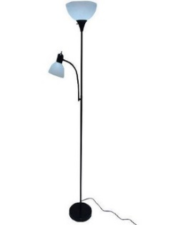  Black and White | 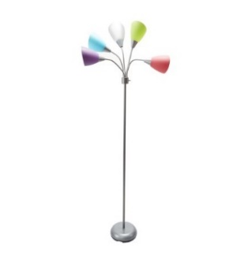  Multi-Colored

Dressers
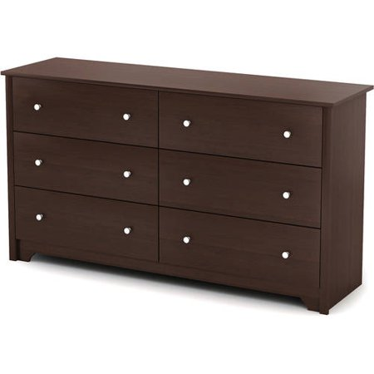  Brown | 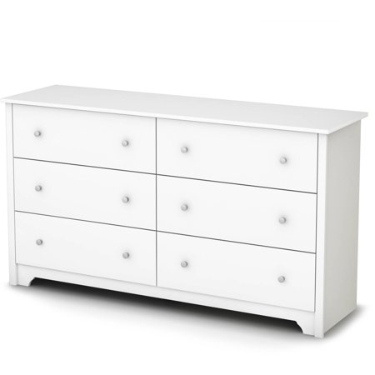  White

Twin Bedding Sets (Includes Sheets, comforter, Pillow Cases, 2 Pillows)
If more than one child in room, indicate quantity of each bedding set desired under checkbox.
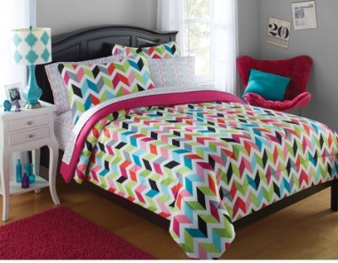  Pink, Blue, Green, Dark Blue | 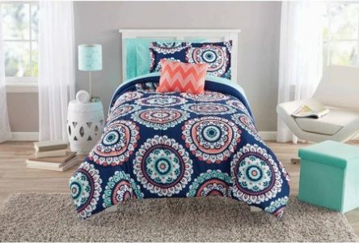  Aqua, Peach, Dark Blue
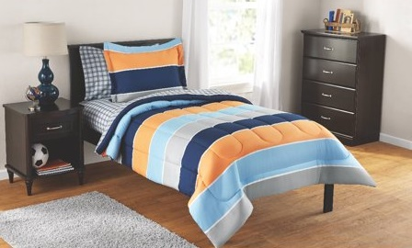  Dark Blue, Light Blue, Orange | 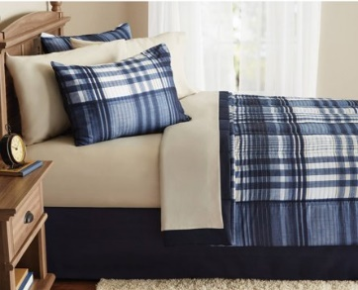  Blue Plaid
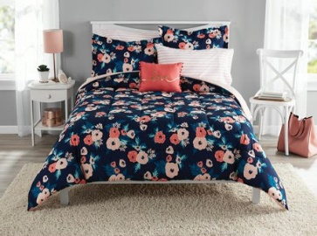  Pink Flowers on Dark Blue | 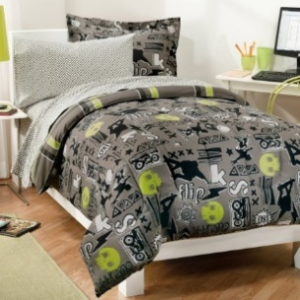  Black, Gray, and Green  (Cats and Skulls Pattern)

Curtain Rods
Quantity: ______

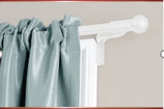  White | 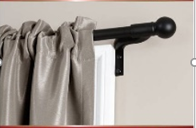  Black

Curtains
Quantity: ______
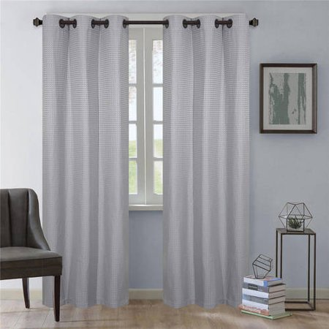  Gray | 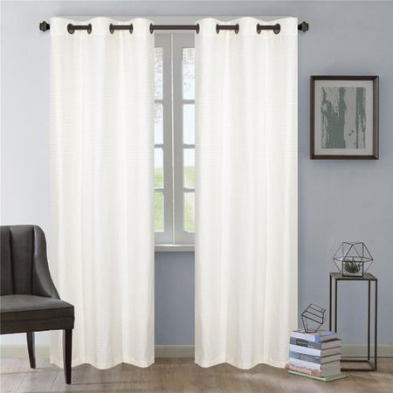  White
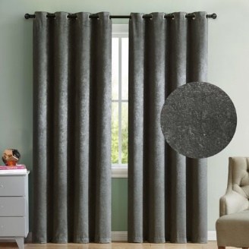  Dark Gray | 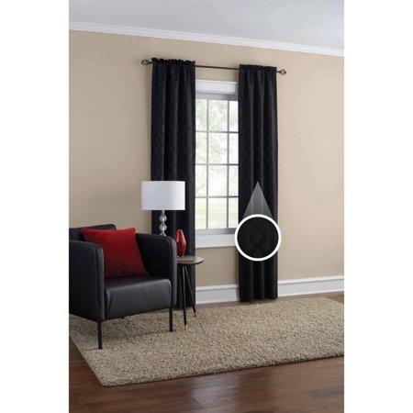  Black

