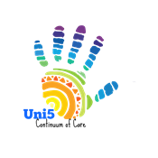

Uni5 Regional Committee of BoS Continuum of Care
(Alexander, Burke, Caldwell, Catawba, & McDowell)
October 18, 2017
Agenda

- Call to Order - Introductions/ Welcome/ Sign In

- Review of Minutes from September

- Coordinated Entry
  - Training

- Balance of State
  - Funding Priorities for our Regional committee
    - Update – Jamie Brown
  - ESG update
    - ESG Lead
    - ESG projects need to be sent to Jamie Brown by Oct. 23, 2017 for review from the fudning committee
  - November in person leadership meeting
    - November 8th in Greensboro
    - All leadership positions invited and encouraged to attend
  - Elections for leadership positions
    - Need to be in place to begin January 1, 2018
    - The leadership positions include:
      - Regional Lead
      - Regional Alternate
      - Coordinated Assessment Lead
        - County leads
      - Funding Lead
      - Point-in-Time Count Lead
        - County leads
      - Webmaster
      - Secretary

- Agency Updates & other Discussions

Adjourn

Next meeting: Next Uni5 Meeting – November 15th Burke County United Way 10am-12pm

