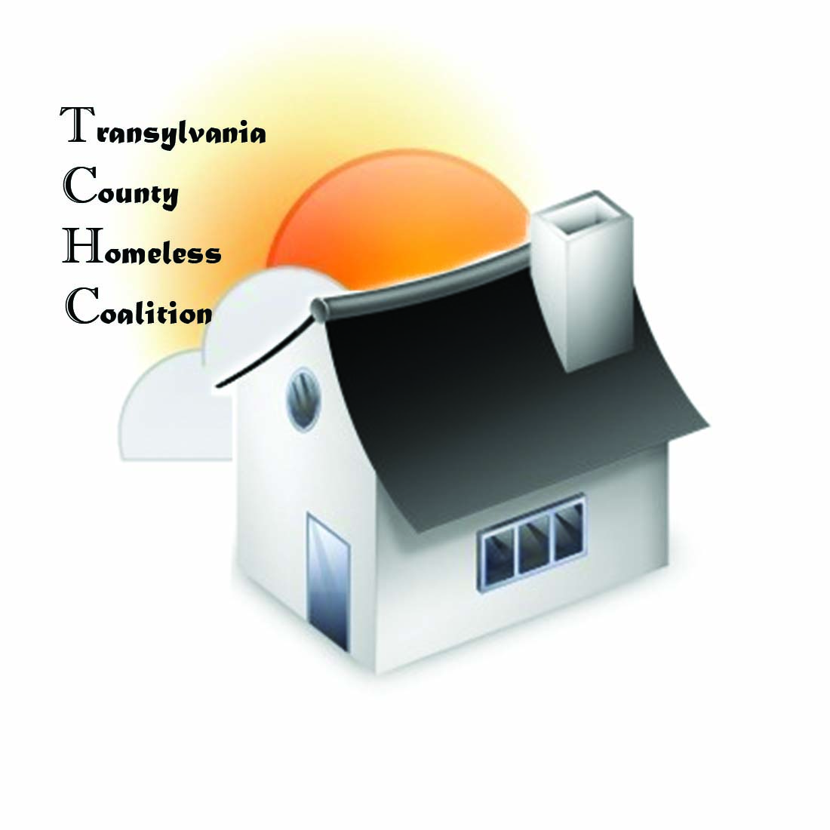
Transylvania County Homeless Coalition
Meeting Minutes

Location: Brevard Housing Authority
133 W. Morgan Street
Brevard, NC 28712
Date: March 3, 2016

Attendees:
  - Jennifer Molliere, Haven
  - Beth Branagan, TCS
  - Shelly Miller, TCS
  - Erika Edwards , SAFE
  - Amy Pointer, Sharing House
  - Charlotte Davis, WCCA

Meeting called to order 9:04
Minutes Approved
- Agency Updates/Introductions

- Haven
  - New board this year. New assistance director has been hired. The Family House is being restructured. For instance; length of stay, expectations and rules for residents will be reviewed. One family has already been asked to leave. A list of options such as self-sufficiency programs and finance classes will become a requirement.
  - There are 2 vacancies at the Family House at this time.
  - Approval to apply for United Way funding between The Haven, SAFE, and Blue Ridge Community Health. Funding request will include check-up for physical and dental health. Mental Health as well, if needed. Prescriptions and transportation to be included as well in this request.
- TRAIN
  - County funding has been submitted with expansion dollars to include a subsidy for an unlimited agreement for TRAIN Database so any agency can join without concern for cost.
  - TRAIN Resource Fairs is also part of the budget request. This would bring resources into the community, especially the remote areas of the county.
  - A community coalition/workgroup list was distributed. TRAIN Roundtable will start presenting coalitions at the meeting. This will be a time for coalitions to share goals, member information and open the floor for feedback from the attendees.
- Sharing House
  - No hot water since last Friday due to gas leak. Expected to be up and running today. This has prohibited neighbors from showering on premise.
  - Getting Ahead is about half way through this class. On Track coming to class and go through credit reports.
  - Heating assistance is still in demand. If there is not a cut off notice, an appointment should be made.
- TCS
  - Teens in Crisis meeting follow up March 8th, Tuesday, 1pm
    - Barbara to sit in to represent TCHC for housing subcommittee
    - A survey was sent out within the school district to assess transportation.
- SAFE
  - Yoga for back pain at Brevard Yoga on 3/29th at 4pm by donation.
  - 1 Billion Rising-April 11th, mob dance flash rehearsals
  - Take Back the Night- April 11th Bonfire and drum circle at Brevard Music Center
- WCCA
  - Self-sufficiency is increasing client base with meeting with clients of SAFE and other programs. Still accepting referrals. Self-Sufficiency is not being entered in TRAIN Database. One on One training will be offered for the database. Referrals can be sent directly to Charlotte. Applications can be mailed out.

- Regional Lead Co-Lead Meeting in Raleigh 3/4/2016

- Coordinated Assessment

  - Hand outs
    - Visual flow chart
    - Copy of approved Coordinated Assessment Plan
      - Jen went over the plan, but too fast for me to type… :-)
  - Implementation needs to occur within 30 days. Quarterly Reports will be required and therefore discussed at the regular coalition meeting.
- PIT
  - Results are in. Total unsheltered homeless is 38 this year. 18 and over count is 24. Chronically homeless (subset of unsheltered) count is 7. Shelter count for Haven was 14. The Family House Count was 15. SAFE count was 7. Couch surfing was not counted this year, but count will be provided.

Meeting adjourned at 9:54am
Next meeting April 7, 2016

