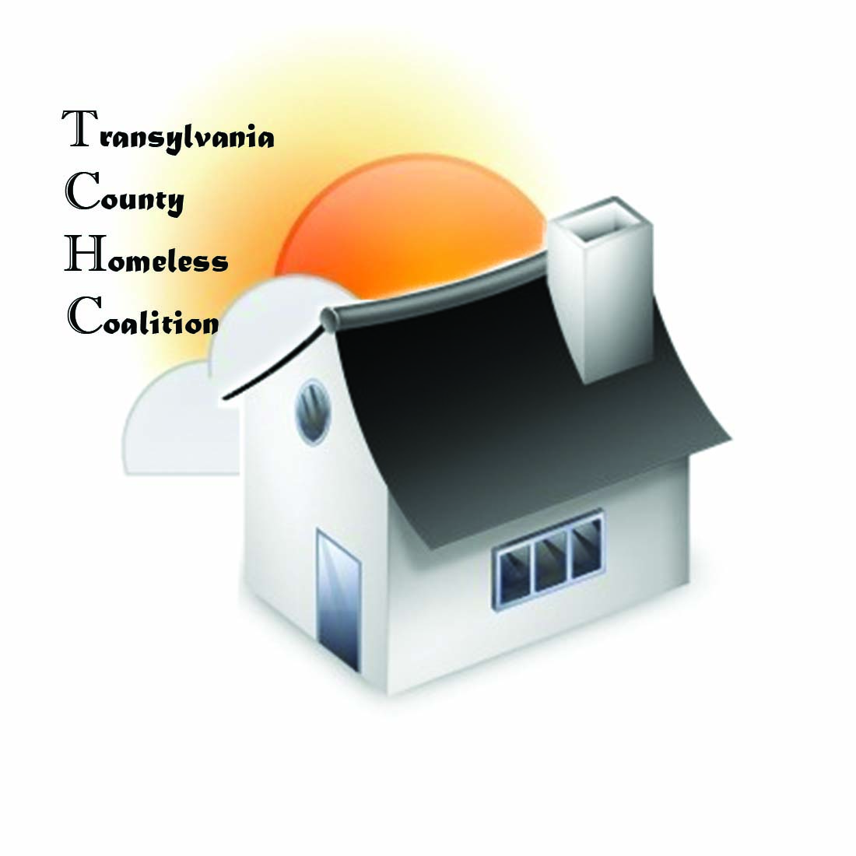
Transylvania County Homeless Coalition
Meeting Minutes

Location: Brevard Housing Authority
133 W. Morgan Street
Brevard, NC 28712
Date: February 4, 2016

Attendees:
Jennifer Molliere, Haven Barbara Marr, TRAIN
Beth Branagan, TCS Shelly Miller, TCS Ron Schieve, CONNECT Amy Pointer, Sharing House
Teesie Stanton, SAFE Amy Upham, Smoky Mountain
Rhodney Norman, BHA Sheila Galloway, WCCA
Emily Lowery, Haven

- Meeting called to order 9:05 am
- Minutes Approved
- Agency Updates/Introductions
  - Haven-
    - Haven Family House – One room open
    - Haven – Male and Female beds available
  - TRAIN –
    - God’s Way event, attendance down but great opportunity for agencies to connect. Would like to set it up like that again as participants came and went through stations
    - Page Lemel wants Teens in Crisis meeting
    - NAACP – diversity resource guide is being worked on to be approved by spring
    - Anchor Baptist has done training on CT and may start entering
    - DSS, raw numbers
    - Volunteertransylvania.org – domain has been bought, add your agency to it, community will have event trying to get people
  - Sharing House – Heating has been big this month
    - Working on large discrepancy, will be doing fundraisers throughout the year
    - Power up fundraiser successful
    - Wheels to Work – gave 3-4 cars in last 2 months, one family has changed drastically because of it and got new housing because of it
    - Getting Ahead Program – have 9 participants, seeing mentors still continuing from last one

  - WCCA – Section 8, wait list 12-18 months
    - Financial Class coming soon – morning classes seem better, discussion was made about Haven Family House and transportation
    - Classes being held at Meridian
  - SAFE – Finished fundraiser Transylvania Got Talent
    - April will be 1,000 rising (not in February)
    - Mindy doing workshops 4:30 – 6, On-Track, nutritional at LCOGS
  - TCS – NCHEP – Beth now a part of it, went to training, using McKinney Vinto, July 1
    - Description definitely changed some about waiting for foster care
    - In the 90’s range for those homeless in school system, usually by the end of year, 120-140 have been counted
    - Teens in Crisis meeting Feb. 16 from 12 -2 community chambers, community meeting on poverty type issues, homelessness and crisis, Page Lemel is trying to get a lot of people to talk about this and come up with a strategy
    - Magnet Box - stem or seam
K-5 K-8, K-12 for each elementary school
Blizzard Bags, round 2 coming out next week, going well, tweaking it some
  - Smoky Mountain – grant for mental illness, housing plan with resources, send Amy housing list for TC and Henderson
  - BHA – behind, 8 vacant units, full by end of month
    - AARP – tax help 9-5
    - 96 on wait list – 2 month – 2 year
  - Feb. 15, Oscar Blues day of giving for Boys & Girls Club, Pisgah Thunder on Pres Day 6 pm
- Coordinated Assessment – resubmitted to be reviewed the 16th, got denied again because of transitional housing, want SAFE to include but theirs is not open to community only DV, wanted to see VISPIDAT was being administered
- PIT – Numbers need to be turned in by 12th and submitted by TCHC by 18th
  - HD is looking at their data, God’s Way got some numbers
  - Street count captured 16
  - Press Release needs to be done when we get numbers, need to specify those from TCS (McKinney Vinto def.)
- TCHC – Needs a mission statement, have a model to look at
  - Changed “to create and implement resources”, Barb will create paper copy
  - Need MOU’s – NCCEH has one preferred to be used we want our numbers to grow creating awareness
- Key &Targeted Housing Program, surprised that we had something besides English House
Meeting Adjourned at 9:56 am
Next Meeting March 3, 2016

