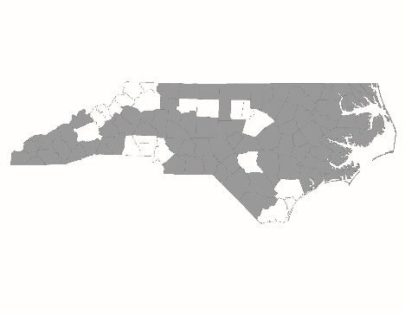

2016 Balance of State CoC Application
New Project Standards Form

New project applications are required to complete and submit this form to NCCEH by 5:00 p.m. on Friday, August 12. Information provided will be used by the Project Review Committee and BoS staff to score and rank new project applications.

Project Information
Applicant Agency:

Project Name:

Project Type (RRH, PSH):

Agency Information
Agency Mission Statement:
Please describe any prior or current experience that the agency has serving homeless households in your community:

Prior Experience with HUD Funding
Has the agency successfully implemented a CoC-funded project of the same project type (PSH or RRH)? | Yes  No
If not, has the agency successfully implemented this same type of project (permanent supportive housing or rapid rehousing) using another funding source? | Yes  No
If the answer to either above question is yes, are the same staff that were operating the program at that time going to be operating the proposed project? | Yes  No
If none of the above, has the agency successfully implemented a different HUD-funded project (ESG, Section 8, HPRP, etc.)? | Yes  No
Existing CoC Grantees:
If the agency has other existing projects, are there any HUD monitoring findings currently associated with any of these projects? | Yes  No
If yes, please explain what the findings were and if they have been resolved:

Number of grant extensions from HUD that were given for a reason other than merging grants:

Statement of Community Need
New CoC projects must demonstrate that they are meeting an existing need in their community. Projects must describe below:
- What community need the new project will address including local data (PIT count, coordinated assessment outcomes, etc.) that demonstrates the need
- How the community has used other resources to address this need

