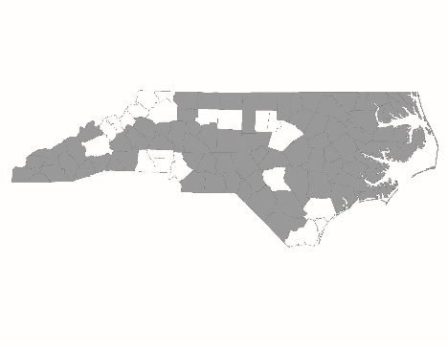

2016 Balance of State CoC Application
New Project Thresholds Form

New project applications are required to complete and submit this form to NCCEH by 5:00 p.m. on Friday, July 29. Information provided will be used by the Project Review Committee and BoS staff to score and rank new project applications.

Project Information
Applicant Agency:

Project Name:

Project Type (RRH, PSH):

Prior Experience with HUD Funding
For RRH projects: Are you currently receiving ESG funds for RRH? | Yes  No
If yes, are you in good standing with the ESG office? | Yes  No
If not, are you currently operating a RRH program with other funding sources that adhere to RRH program standards as outlined in the New Project Scorecard? | Yes  No

Agency Information
Has the agency been in operation for at least 3 years? | Yes  No

Performance
Does the agency commit to enter 100% of the beds into HMIS (with client consent)? | Yes  No

Agency’s Relationship to Community
Does the agency agree to participate in the local Coordinated Assessment process as designed by your Regional Committee(s)? | Yes  No

