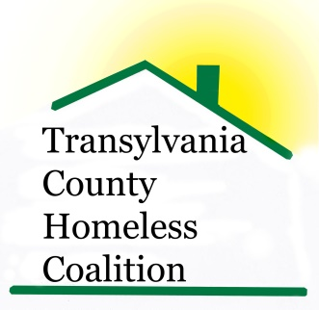
Transylvania County Homeless Coalition
Meeting Minutes

Location: Brevard Housing Authority
133 W. Morgan Street
Brevard, NC 28712
Date: November 7, 2014

Attendees:
Jennifer Flood, Haven Rhodney Norman, BHA
Kaitlin Higgins, TCDHP Beth Branagan, TCS
Ashley Ramer, Brevard High School Sheila Galloway, WCCA
Sarah Lancaster, SMCME/MCO Louise Egerton, ESG CM
Kaitlin Huggins, TCHD Susan Lefler, Community Liaison
Emily Lowery, Haven

- Meeting called to order 9:00 am
- Minutes Approved
- Introductions and Agency Updates/New News
  - Haven- 12 residents male and female beds available, Family Shelter full
  - BHA- Renovations underway, no vacancies with preference 6 month waiting list, without preference 8-14 months wait
  - TCS- 68 homeless have been identified so far this year, 141 last year, this year counting pre-school as well
  - WCCA- Self-Sufficiency Class Open ages preschool to senior, Offering a Financial Class through On-Track
  - Community- Gutters and Alleyways book is now available on Amazon
- Christmas- Everything will be entered on Charity Tracker so clients will not double-up on services, 250 children on Angel Tree with the TCS
- ESG- have not received contract yet, have received first reimbursement check, was able to pay the fiscal sponsor (Haven) some of what was owed $2K left over to pay, moving forward will not be able to pay client’s back rent if large amount
- HOME Funds- Rent will be paid after ESG pays client’s deposit for up to 6 months
  - Haven takes application and sends them to Cheryl at WCCA
  - This program will enable clients to save some money during first few months of tenancy
  - We have not received the application back

- Coordinated Assessment Tool discussion
  - Coalition decided to keep doing intakes as we do now through the Haven
  - Forms will be accessible to coalition members on Charity Tracker and a tab on Haven’s page of all forms
  - Haven will post waiting list on Charity Tracker
  - Haven will be doing assessments and putting clients on waiting list
- Blanket Drive going on now, donations may be dropped off at Haven for outreach closer to Point in Time in January
  - Check into Kmart, Walmart, Goodwill, Dollar Store if a drop box may be left there for collection
- Code Purple- Looking for a facility to hold this
  - Churches have already donated food
  - Need pet friendly facility with showers
  - Discussion of possible facilities are: BCC, FUMC, Turf, Community BLDG, Rec. Dept.
- Point in Time, January 28th
  - Need volunteers
  - Do a public service announcement in TTimes
  - Need to contact Forest Rangers for assistance
- Next meeting scheduled for December 4, 2014
- Meeting adjourned at 10 am

