0632 HMIS APR – How to run and review the report for data quality issues  
  
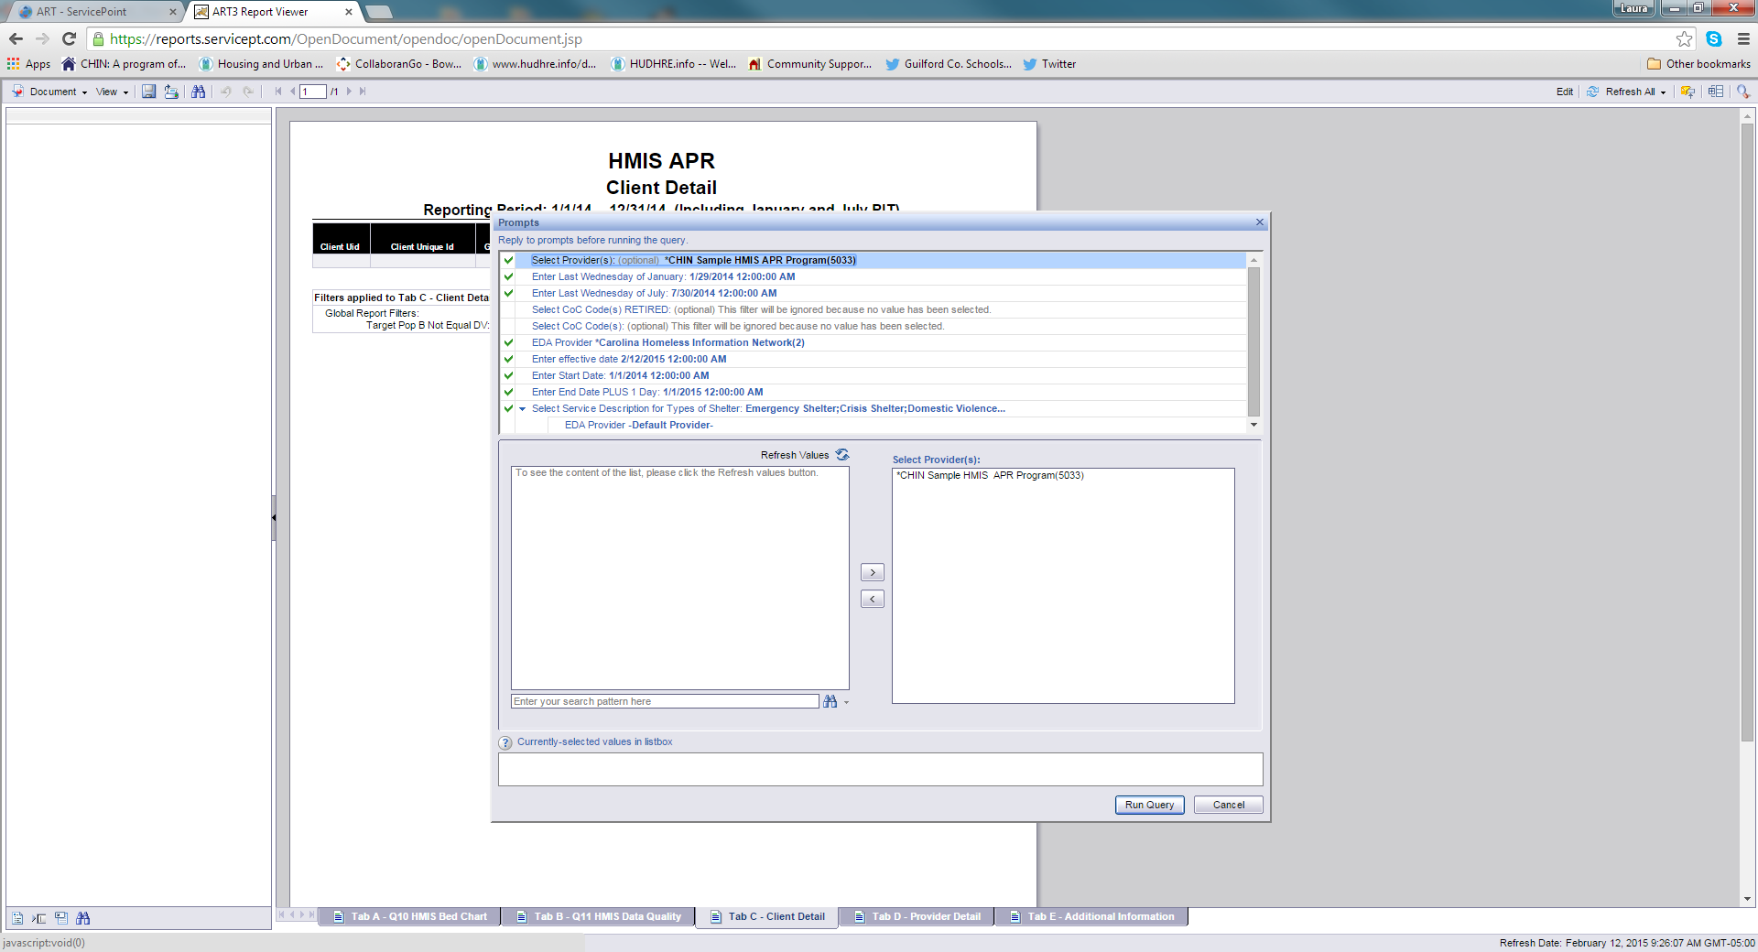

Answer the prompts and click Run Query (or schedule the report and answer the prompts there)

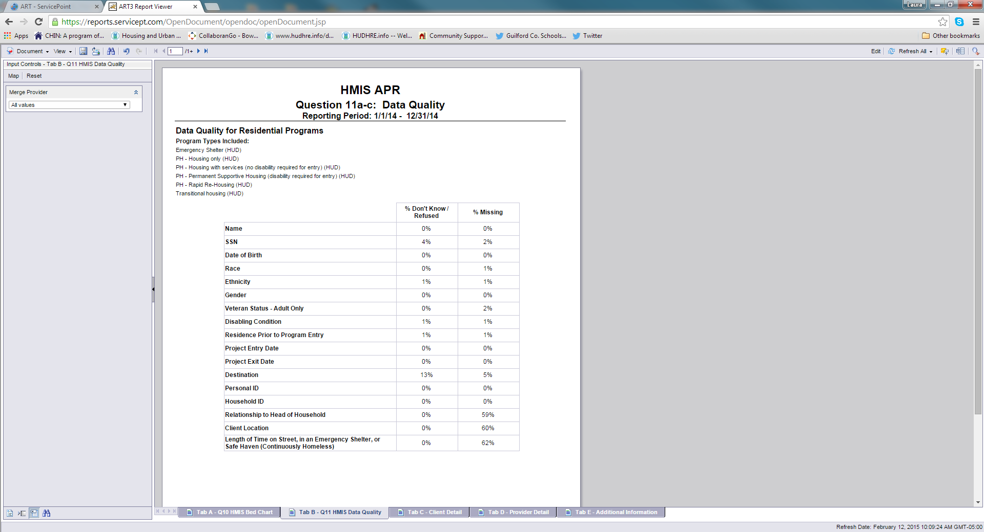

Tab B checks on Data Quality for all clients in all projects in the report during the Reporting Period.

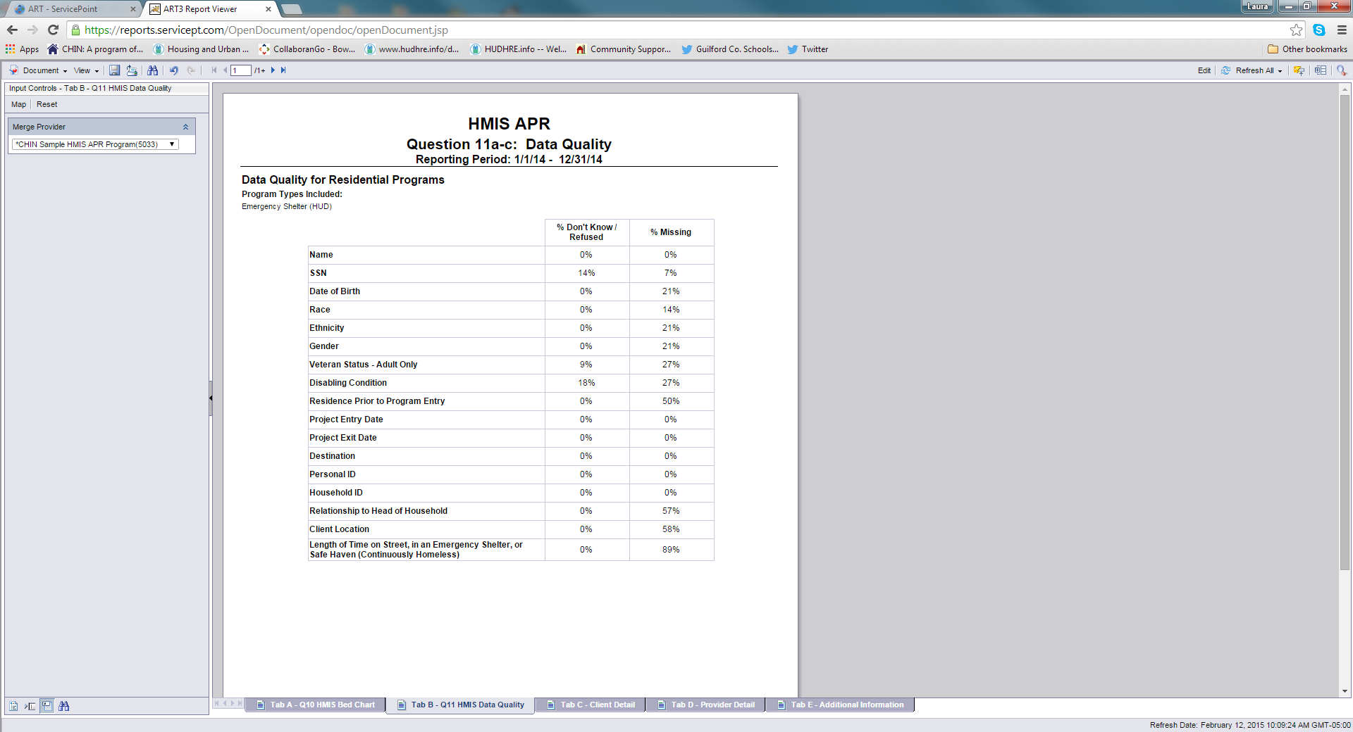

While you are in ART, you can use the Input Controls feature to filter a tab to show only selected data. Click on the Input Controls icon to use the feature.



In Tab B, you can filter the DQ table to show Data Quality for a single project by selecting that project from the list. You can then download that report or view it on the screen.

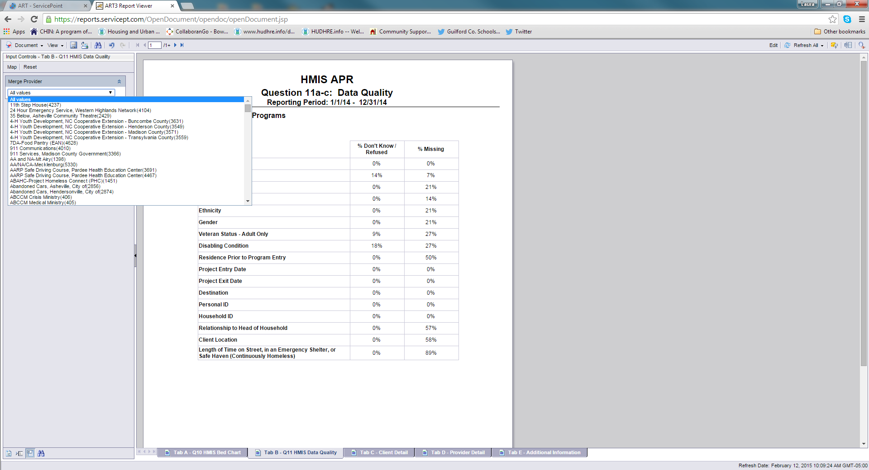

Be sure to clear out the Input Controls when you are finished by selecting All values.

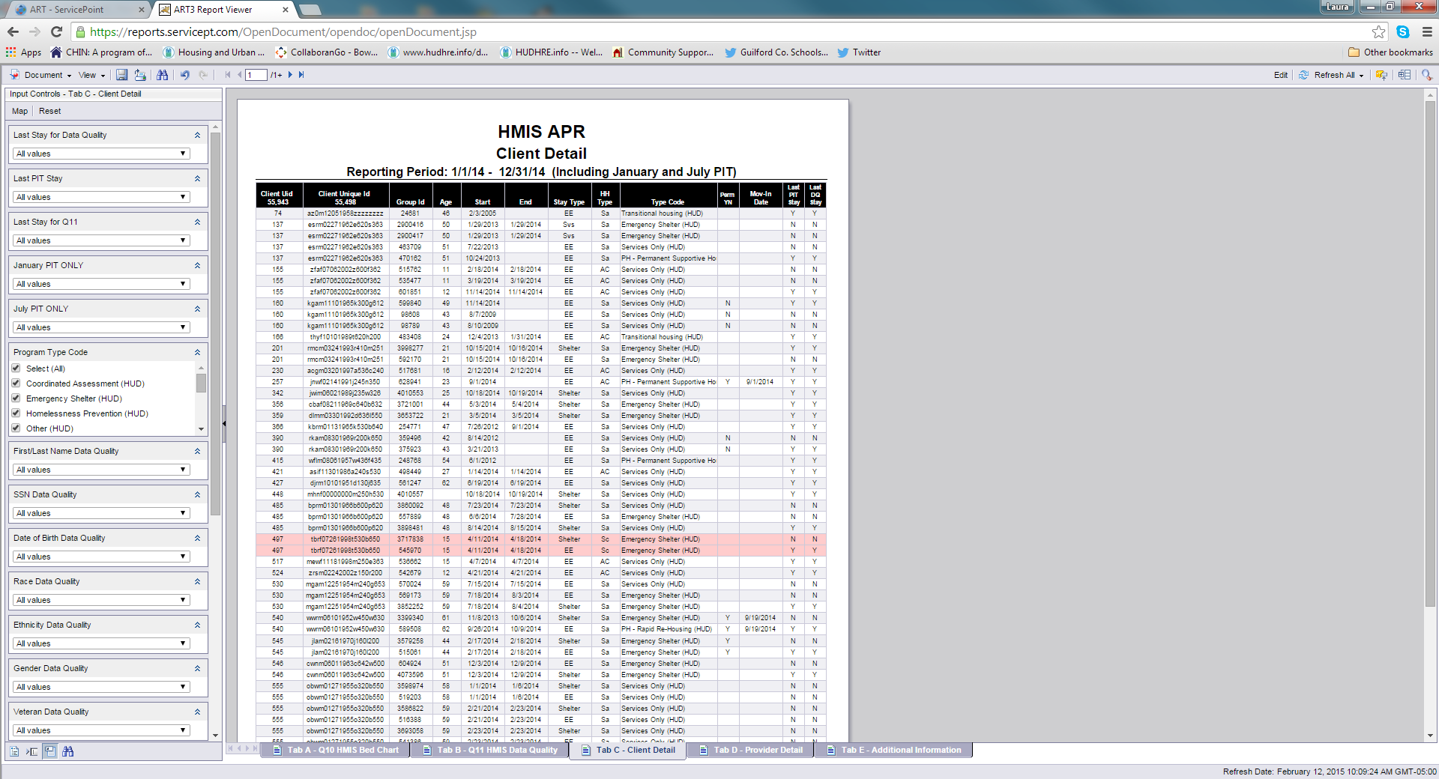

Tab C lists the clients in the report and shows some of the data that is pulled into the report.



Tab C includes several different Input Control options. You can combine Input Control filters to show specific lists of clients but make sure you keep track of the Input Controls that are being used.

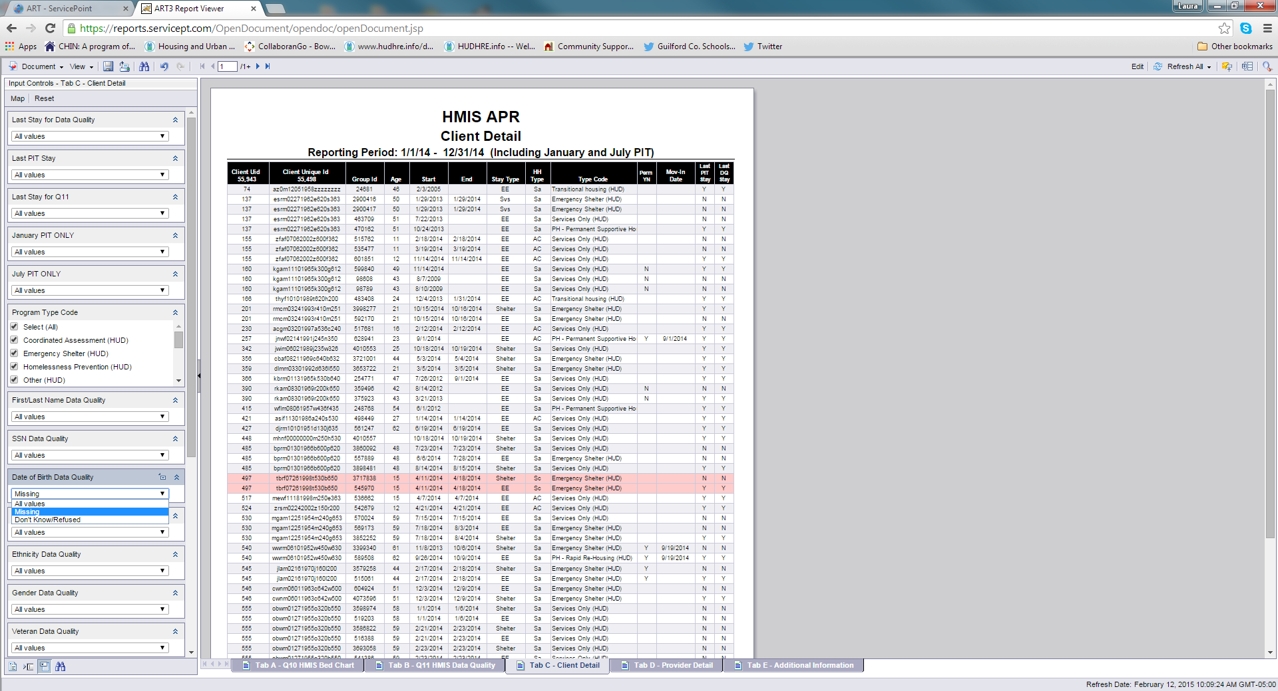

To filter by clients missing Date of Birth, select Missing under Date of Birth Data Quality.

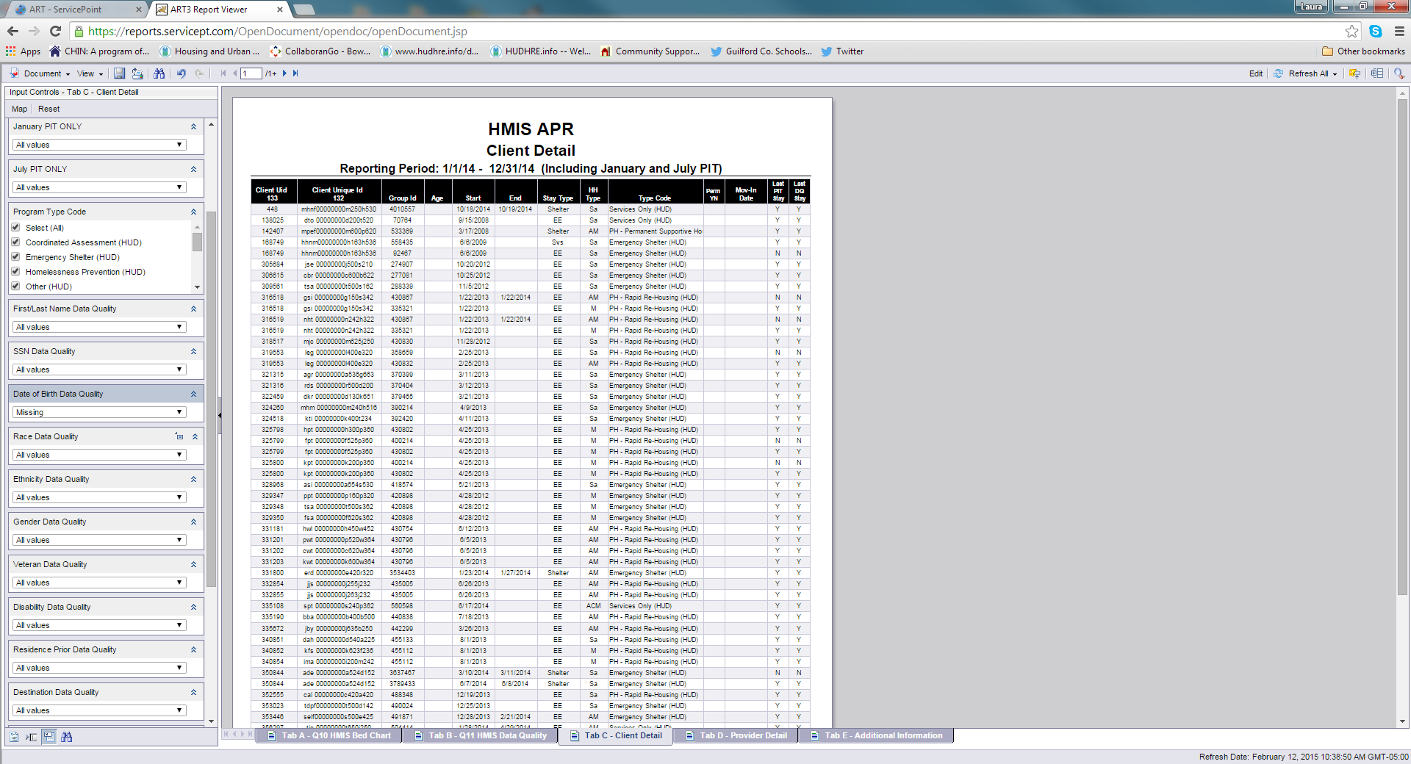

Since Age is a column in this table, you can see that the table is filtered to show only clients who are missing DOB.

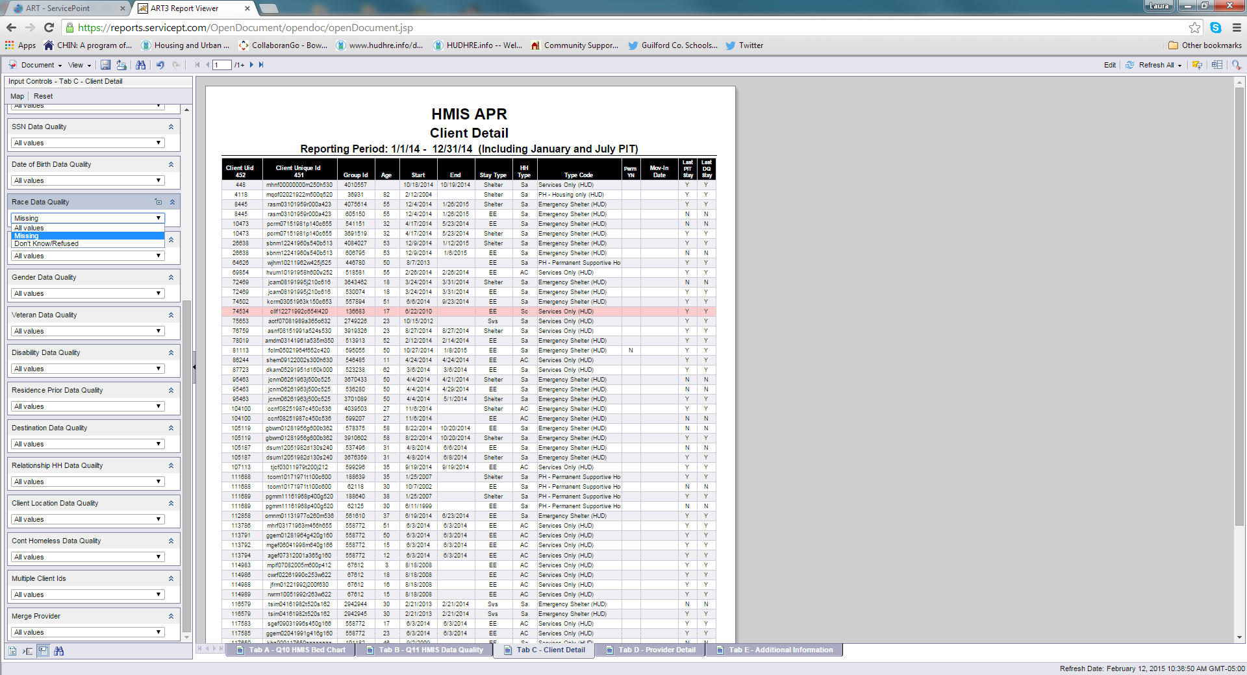

We reset the Date of Birth Data Quality and will now filter our table to show clients with Race Data Quality Missing.

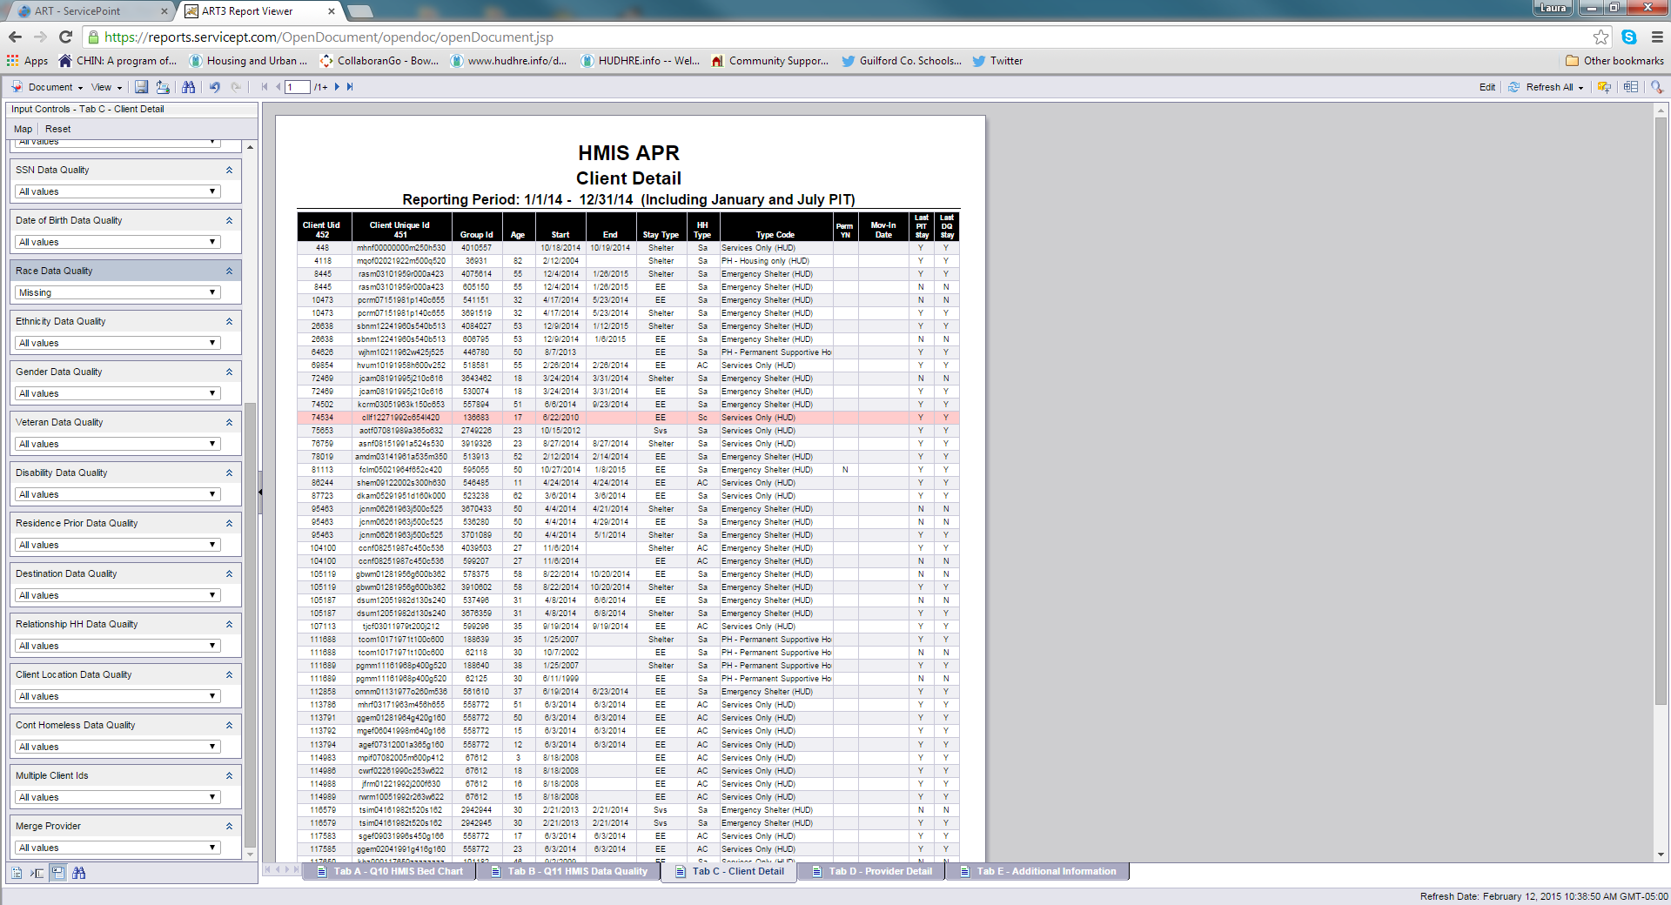

When the table refreshes, we have a filtered list of clients who are missing race. However, we don’t have a column for race to show us that. If we click on the last page icon, we can see what Input Controls are active.

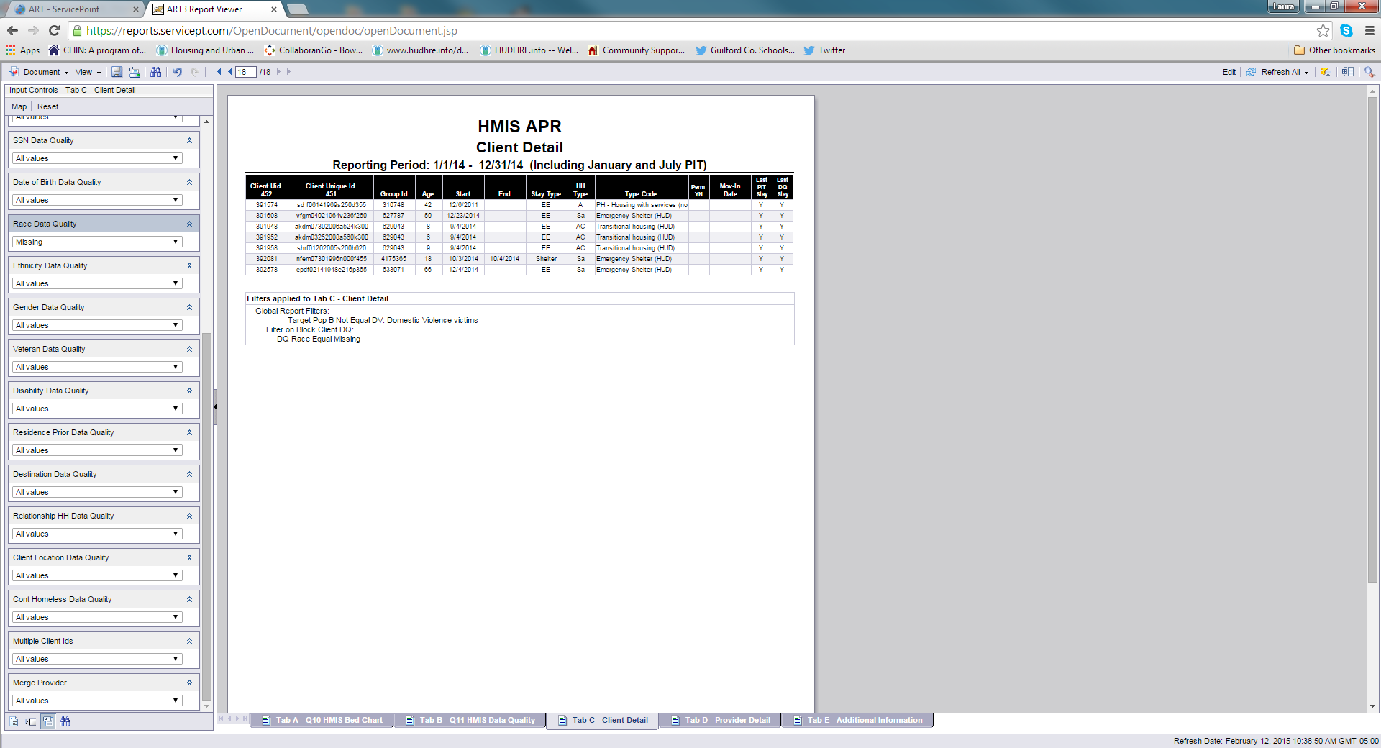

At the bottom of the table, there is a list of the filters that are applied to the tab. We can see here that Race Data Quality=Missing is applied to the table.

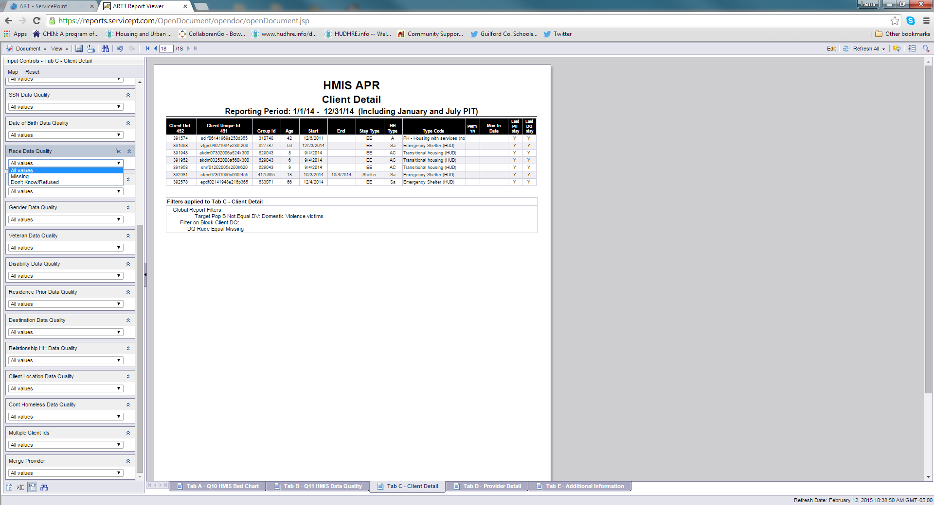

Remember to reset to All values when you are finished using an Input Control.

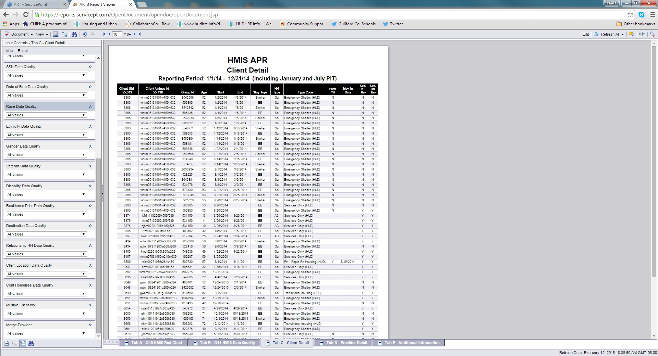

Tab C has a lot of Input Controls, so be sure to scroll to the bottom to see all of the options. CHIN has added Merge Provider as an Input Control so that you can filter this tab to see all clients from a single project.



Notice that this tab shows the responses to the fields “In Permanent Housing” and “If yes, Date of Move-In”. These 2 fields must be completed for Rapid Rehousing projects for the Point in Time and the HMIS APR. Filter this tab to show RRH proects and then clients missing that info.

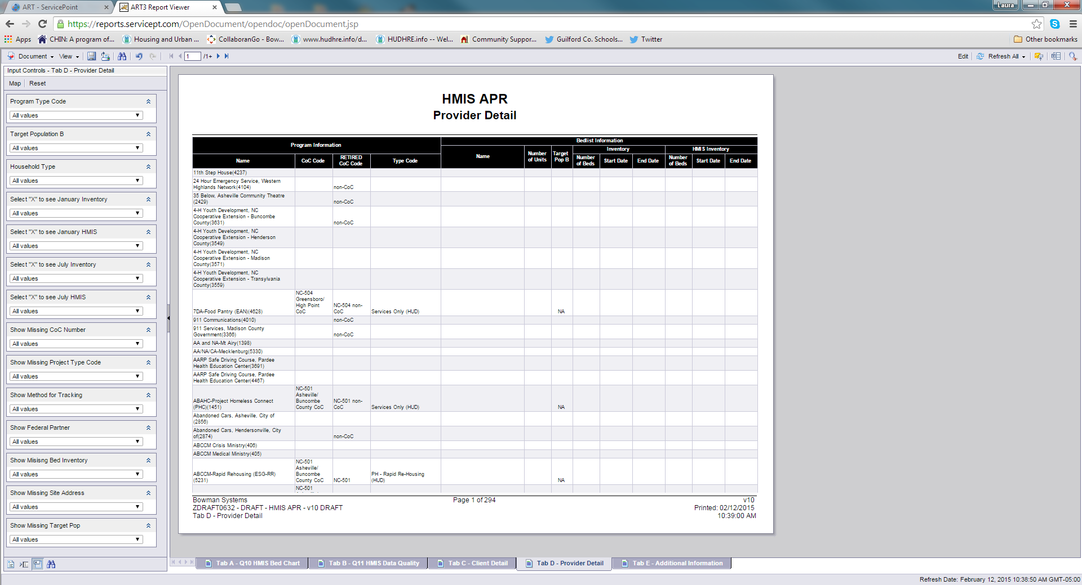

Tab D shows the agencies and projects included in the report. There are several Input Controls on this tab. You can use these filters to see which need to have information entered into their provider pages.