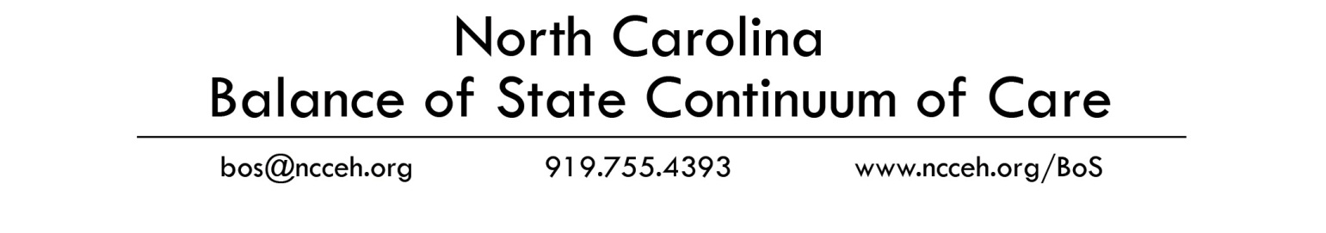
2012 Balance of State Regional Committee Project Application Approval Form
Name of Applicant Agency | Project Name | Project Type  (PH-PSH, PH-RRH, TH, SSO) | New/  Renewal (N/R) | Total Amount of Funding Requested | Approved?  (Y/N) | Date of Reg. Comm. Meeting When Approved  (mm/dd/yy)  If electronic vote, mark “e-vote” | Priority  (1, 2, 3, etc.)
United Community Ministries | UCM PH Renewal | PH-PSH | R | $89,238
United Community Ministries | UCM Bassett TH Renewal | TH | R | $89,880
 |  |  |  | $
 |  |  |  | $
 |  |  |  | $
 |  |  |  | $
 |  |  |  | $
 |  |  |  | $
 |  |  |  | $
 |  |  |  | $

This form certifies that all Continuum of Care funding applications in this region have been reviewed by the Regional Committee and that the priority assigned to them has been determined by committee vote.
Region: Twin County
Name of Regional Committee Lead: Chris Battle
Signature: __________________________________________________________________________Date:
Please submit this signed form and a copy of the meeting minutes at which the vote took place to NCCEH.
Email: bos@ncceh.org Fax: 888-742-3465

