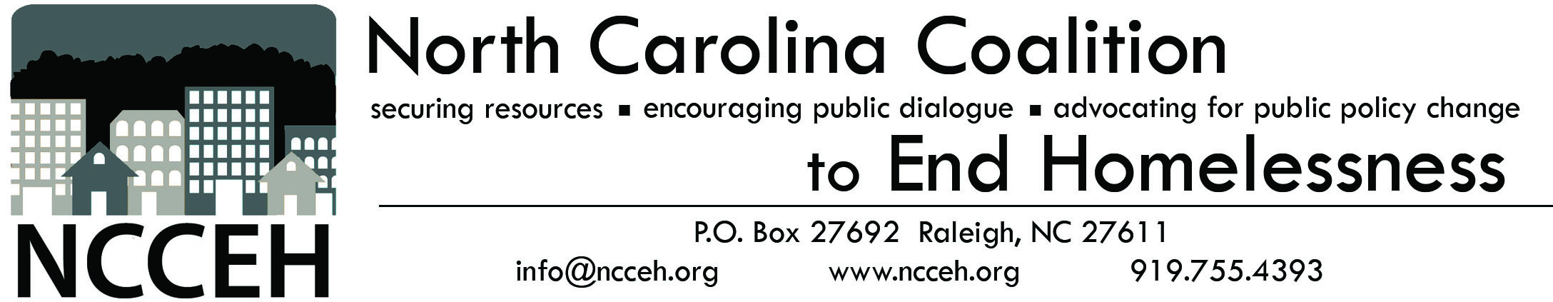
Former Adult Care Home Resident Form

Some of North Carolina’s Adult Care Homes, also called Rest Homes and Assisted Living, are undergoing transitions that may result in homelessness of former residents. In order to advocate for proper housing resources and services, NC Coalition to End Homelessness is asking for information regarding these individuals. Please fax this form and the signed Consent for Release to NC Coalition to End Homelessness at 1-888-742-3465.

AGENCY INFORMATION
Agency Name:
Agency Location (City/County):
Staff/Volunteer Completing Form:
Contact Name (if different):
Contact Email Address:
Contact Phone Number:
Did you enter ACH information into CHIN? | Yes No
Today’s Date:
INDIVIDUAL INFORMATION
Individual Name:
Date of Birth:
Race:
Gender: |  | Male Female
Are you currently enrolled in Medicaid? |  | Yes No
Do you currently have SSI/SSDI income? |  | Yes No
Are you connected to a Service Provider? |  | Yes No
If not, do you need help with being connected?
Do you have access to needed medications? |  | Yes No
If not, do you need help with getting medication?
ADULT CARE HOME INFORMATION
Adult Care Home Name:
Adult Care Home Location (City/County):
How long did you reside at this Adult Care Home?
Date Left Adult Care Home:
Where did you go first after leaving Adult Care Home?
How did you get to the shelter?

Questions? Contact NCCEH at (919)755-4393 or emily@ncceh.org

