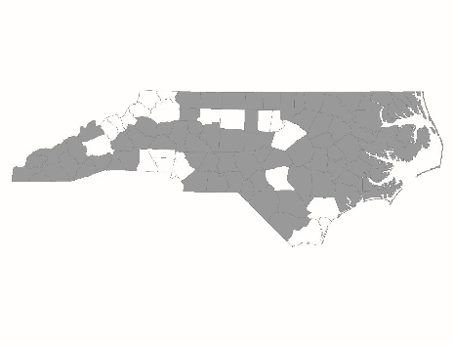

New Applicant
SSO-Street Outreach
Policies and Procedures Page Reference Form

Applicant:
Project Name:

Page References
The following chart lists program design and other elements that the CoC scores based on documentation submitted by the agency. For each element in the chart, please list the policies and procedures’ page number(s) on which the item appears. If the element does not appear in the program’s policies and procedures, mark the cell as N/A.

Scorecard Question Number | Program Design Element | Page Number(s)
2.2a | Subpopulation targeting
2.4b | Eligibility requirements
2.4c | Reasons for termination
2.7 | Harm Reduction
2.8 | Trauma-Informed Care
4.4 | Anti-Discrimination Policy

