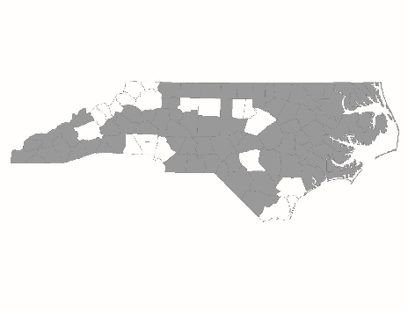

Renewal Applicant
Rapid Re-Housing Form

Applicant:
Project Name:

Page References
The following chart lists program design and other elements that the CoC scores based on documentation submitted by the agency. For each element in the chart, please list the policies and procedures’ page number(s) on which the item appears. If the element does not appear in the program’s policies and procedures, mark the cell as N/A.

Scorecard Question Number | Program Design Element | Page Number(s)
2.1a | Eligibility requirements
2.1b | Reasons for termination
2.3a1 | Housing location services
2.3a2 | Housing location policies
2.3a3 | Landlord support
2.3a4 | Staff supporting tenancy rights
2.3b1 | Staff programmatic onboarding and training
2.3b2 | Assistance policies
2.3b3 | Progressive approach
2.3c1 | Client choice
2.3c2 | Voluntary participation
2.3c3 | Employment connections
2.3c4 | Case management support
2.3d1 | Staff program design onboarding and training
2.3d2 | Screening processes
2.3d3 | Low barrier program enrollment
2.3d4 | Standard leasing
3.1 | Targeting Subpopulations

Services Resource Leverage Plan
Describe how the project will leverage services funding for its clients and the long-range plan for decreasing the usage of HUD funding for supportive services and increasing the usage of HUD funding rental assistance in the CoC project. Include in your description any formal relationships with other agencies where an MOU/MOA is in place, any dedicated funding streams that will provide services for program participants, and the percentage of match dollars for services the project has procured over the required 25%. If the project has formal MOU/MOAs in place, please submit with this form as part of the application package.

HUD Monitoring
Has HUD issued any monitoring findings for the listed project?

If yes, please list the individual monitoring findings and explain how these have been resolved with the HUD Field Office.

Grant Extensions
How many grant extensions from HUD were given for a reason other than merging grants in fiscal years 2016, 2017, and 2018?

Coordinated Entry
VI-SPDAT Scores:
During CY2018, how many new households entered the RRH program?
List the VI-SPDAT scores for each new head of household that entered during the year:
HMIS ID: | VI-SPDAT Score:
HMIS ID: | VI-SPDAT Score:
HMIS ID: | VI-SPDAT Score:
HMIS ID: | VI-SPDAT Score:
HMIS ID: | VI-SPDAT Score:
HMIS ID: | VI-SPDAT Score:
HMIS ID: | VI-SPDAT Score:
HMIS ID: | VI-SPDAT Score:
HMIS ID: | VI-SPDAT Score:
HMIS ID: | VI-SPDAT Score:
HMIS ID: | VI-SPDAT Score:
HMIS ID: | VI-SPDAT Score:
HMIS ID: | VI-SPDAT Score:
HMIS ID: | VI-SPDAT Score:
HMIS ID: | VI-SPDAT Score:
HMIS ID: | VI-SPDAT Score:
HMIS ID: | VI-SPDAT Score:
HMIS ID: | VI-SPDAT Score:
HMIS ID: | VI-SPDAT Score:
HMIS ID: | VI-SPDAT Score:
HMIS ID: | VI-SPDAT Score:
HMIS ID: | VI-SPDAT Score:
HMIS ID: | VI-SPDAT Score:
HMIS ID: | VI-SPDAT Score:
HMIS ID: | VI-SPDAT Score:
HMIS ID: | VI-SPDAT Score:
HMIS ID: | VI-SPDAT Score:
HMIS ID: | VI-SPDAT Score:
HMIS ID: | VI-SPDAT Score:
HMIS ID: | VI-SPDAT Score:
HMIS ID: | VI-SPDAT Score:
HMIS ID: | VI-SPDAT Score:
HMIS ID: | VI-SPDAT Score:
HMIS ID: | VI-SPDAT Score:
HMIS ID: | VI-SPDAT Score:
HMIS ID: | VI-SPDAT Score:
HMIS ID: | VI-SPDAT Score:
HMIS ID: | VI-SPDAT Score:
HMIS ID: | VI-SPDAT Score:
HMIS ID: | VI-SPDAT Score:
HMIS ID: | VI-SPDAT Score:
HMIS ID: | VI-SPDAT Score:
HMIS ID: | VI-SPDAT Score:
HMIS ID: | VI-SPDAT Score:
HMIS ID: | VI-SPDAT Score:
HMIS ID: | VI-SPDAT Score:
HMIS ID: | VI-SPDAT Score:
HMIS ID: | VI-SPDAT Score:
HMIS ID: | VI-SPDAT Score:
HMIS ID: | VI-SPDAT Score:
HMIS ID: | VI-SPDAT Score:
HMIS ID: | VI-SPDAT Score:
HMIS ID: | VI-SPDAT Score:
HMIS ID: | VI-SPDAT Score:
HMIS ID: | VI-SPDAT Score:
HMIS ID: | VI-SPDAT Score:
HMIS ID: | VI-SPDAT Score:
HMIS ID: | VI-SPDAT Score:
HMIS ID: | VI-SPDAT Score:

