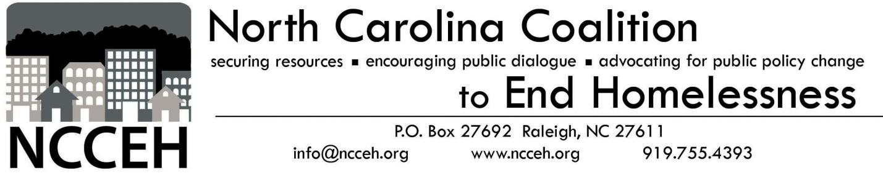

Veteran Micro-Housing:
Pride, Purpose, Community

Fall 2018

Veteran Homelessness in North Carolina
State and federal agencies are concerned with veteran homelessness. In 2010, President Barack Obama announced an objective to end veteran homelessness. In 2015, North Carolina Governor Pat McCrory vowed to end homelessness in the state and Governor Cooper has since reaffirmed that vow. Both state and federal government bodies made significant progress. As of 2017, there are roughly 40,000 homeless veterans nationally, a 47% reduction from 2010. As of 2016, there were an estimated 888 homeless veterans in North Carolina, a 37% reduction since 2013. While North Carolina has fared better at reducing veteran homelessness relative to other states, the state has not yet ended veteran homelessness.

A gap analysis focused on the January 2017 to December 2018 timeframe, predicts that 5,676 veterans will experience an episode of homelessness in North Carolina. These estimates also predict that 1,971 veterans will become chronically homeless in that timeframe. Housing providers must secure almost 8,000 housing units to house all veterans. While 76% of homeless veterans live in metropolitan regions, a substantial number live in rural areas. Demographically, 85% of homeless veterans are male, and 85% of veterans who have experienced homelessness are single. These demographic trends should inform housing interventions, but not limit them.

Veterans reacclimating to civilian life face unique challenges. Returning from service, veterans commonly battle anxiety, depression, and physical ailments as a consequence of their service. Substance abuse is a common coping mechanism. As a result, some veterans have trouble maintaining civilian employment, often limiting their ability to afford market-priced housing.

What is Human-Centered Design?
What can be done to end veteran homelessness in the Tar Heel State? Terry Allebaugh of the North Carolina Coalition to End Homelessness and Duke University believed micro-housing could be a viable solution. Through conversations with students at Duke, he realized it would be useful to ask veterans whether micro-housing might be a desirable option. Our team of Duke University Sanford School of Public Policy alumni used a human-centered design (HCD) framework to research what homeless veterans want and need from a housing intervention. The team used this framework because HCD addresses the emotional experience of the intended beneficiaries of a policy or intervention. Human-centered design starts with understanding the people and then using their needs and desires to co-design a solution. HCD is a framework for thinking and a three-phase design process.

Discover

Design

Deliver & Measure

Our team tackled the “discover” phase of the process. In this step, we conducted in-depth personal interviews and asked veterans directly about their housing needs. Our team typically conducted interviews in the homes of veterans who previously experienced homelessness or in a shelter for those currently experiencing homelessness; we simply had a conversation. We came prepared with some interview questions, but the conversation was unscripted. Here is a sampling of the interview questions:
- What does “home” mean to you?
- Is your current housing satisfactory to you? What makes it so or not so? If you could change one thing about it, what would it be?
- What are the important structural elements of a home? What is really needed? What is just nice to have? Can you draw it for us?
- When you think of your home, either what you have or what you wished you could have, how much space do you think you need or would like? (prompt with “in terms of square footage, or number of rooms, what do you think is the best range?” if necessary)

Our interview pool consisted of veterans who have experienced homelessness, homelessness prevention nonprofit caseworkers, staff from the North Carolina Department of Military and Veterans Affairs, and North Carolina Department of Health and Human Services. We interviewed both male and female veterans, with a majority being male. We spoke to servicemen and women the Army, Air Force, Marines and Navy and from different conflicts ranging from Vietnam to the Global War on Terror, as well as a peacetime veteran. Our interviewees had different experiences separating from the military, resulting in a diverse range of discharge statuses. We spoke to African American and white veterans, with an overrepresentation of African American veterans. While we recognize that our pool is limited, we believe that we captured a diverse set of experiences. The memo that follows details our findings in the form of themes and insights gained in our conversations with veterans about their experiences and housing needs.

Findings: From the Veterans Themselves
The long, ethnographic interviews revealed themes of community, structure, and purpose. Expressed wishes support these themes, some of which are reflected here in direct quotations from the veterans.

Community
Home is personalized reflection of self.
Home is a place where veterans regain their pride. From the moment they enlist, the military trains servicemembers to be proud. Failure is not an option. When service members exit the military and fail to find or keep a home, they consider it a personal failure, another instance where pride is lost. We heard stories of veterans experiencing homelessness who couldn’t lift their heads crossing the street; one even committing suicide by walking across an interstate.

Veterans consider home as a sanctuary; a safe place to go when they can’t go anywhere else. It is a place to relax and be themselves. Home is a place where they can restore pride in themselves and their achievements. It is a reflection of who they are. “My dreams were shattered. I felt like a failure. I was trained to be a winner. There was a lot of shame and guilt. I couldn’t tell my family about it; it had a lot to do with pride. I didn’t want to go them to get help.”

Maximize purposefulness, minimize feelings of isolation.
The transition from the military to the civilian world is difficult. Servicemembers had their “three hots and a cot” -- their meals and housing -- taken care of from the time they were 18 years old. They were told where to go, what to do, what to wear, and how to behave in a very insular society. The transition can be harsh, unforgiving, and bewildering when all of that familiarity and structure disappears. Veterans are leaping into a society that increasingly does not understand their experiences. Active duty personnel make up less than 0.5% of the U.S. population. Transition is even more difficult for those who separate from the service with little familial support or “other than honorable” or “dishonorable” discharges. These feelings were expressed by several veterans: “I was surprised by how much I didn’t know about living.” “I didn’t know what to do.” “I had no support.” The housing solution needs to maximize purposefulness through jobs or contributions to the community so the veterans can create routine, order, and pride and minimize those feelings of isolation. Veterans are already isolated from civilians simply due to their service. Where they live shouldn’t further isolate them.
Personal space is important, but veterans need a community where they do not have to explain themselves.
As can so often happen in human-centered design, findings from human observation can be contradictory; so researchers have to strike a balance. The next observation exemplifies this tension. Home is a place to get away, be separate, decompress, but still be part of a community.
Every single person interviewed noted that they do not like sharing walls in typical apartment-style units. Unknown sounds from neighboring units are unwelcome and is another reminder of lost control and a stress trigger. Veterans want their own space. But, there is also a desire to have a community that “gets it” and “where everyone is on your side.” The housing solution needs to build in personal space, but still foster community. Ideas for community events in community spaces included: group exercise, barbeques, group therapy sessions, and welcome and farewell gatherings. Pocket communities situated around a green space, community center or picnic shelter were suggested ways to create community while preserving individual space.

Structure
While the emotional elements are important, veterans still experiencing homelessness shared several key structural insights to incorporate into micro-housing solutions.

Simplicity and normalcy are paramount.
No one is looking for an ornate home; just a safe, quiet place to put their lives back together. Making each unit look similar is helpful from a design standpoint, and is something veterans who have lived in base housing or barracks are used to. We heard from several: “Just normal stuff. It don’t need to be fancy.” “Make it like base housing.”

With simpler designs, veterans could learn to build the houses themselves. Some were interested in housing construction as a pathway to a job and income. Veterans want to contribute to their community, but also find a job. Building homes or repairing existing units could accomplish both goals. This would increase purposefulness, satisfy the stated need for normalcy, and establish a readily available workforce for constructing and maintaining units.
Safety and security are very important.
The first word we heard from every single participant in our study when asked what home meant for them was either “safe” or “secure.” These units need to have all the physical trappings of security and safety. The individual units should have good locks on doors and windows, screen doors and peepholes. Clear sightlines from front to back and side to side through the units were important to many in the cohort, but so was having a separate sleeping quarter. Again, the design must strike a balance. The community should have security measures built into it such as community watch, a gate, or patrols.
Storage solutions are required.
After not having a home, study participants wanted storage. They want to put the few possessions they have in its place. Storage helps to make a home a more personalized reflection of who they are now, instead of who they used to be during homelessness. Many were accustomed to a tidy existence in the military. Homelessness destroys that. A tidy space of their own starts the rebuilding of pride.

Micro-homes should be soundproofed.
Study participants wanted quiet homes that don’t share walls. Ideally, our design would include soundproofed walls and situate units far enough apart so outside noises do not penetrate as easily.

Veterans desire creature comforts too.
The suggestions listed below include details that would make the units more comfortable and user-friendly. This information comes directly from veteran interviews:
- Fan and light in bathroom on different switches (noise concerns)
- Secure place to put clothes (security, pride)
- Storage for cleaning and cooking supplies (security, pride)
- 1-bedroom that is somewhat partitioned from other parts of the house (security, pride)
- Furnished (practical, coming with very little)
- A mailbox (important for those trying to find work, get VA health things sorted out)
- Yard or space around the front and sides of the units (both for that sense of space and sense of security)
- Close to medical care, grocery store, church, gas station and mechanic (practical)
- Multi-purpose room or community center where group activities can be held (community)
Purpose
Pride and failure are a big part of the homelessness experience.
When failure does happen, even if it’s just incorrectly filling out a form or missing an appointment, it creates another layer of shame. Supportive services that help veterans deal with and move on from past failures should be part of the solution. When veterans have a space that is distinctly theirs, they can begin to regain their pride and release their shame.

First, Home - First Home
A home is the first step toward regaining the self esteem and self-sufficiency needed to reintegrate into society. Veterans need an address to send or receive mail can be sent or to list on a job application. As a practical matter, micro-housing seems best suited for those that are still experiencing homelessness. Our study participants who had been supportively or permanently housed in an apartment or house did not find micro-housing suitable. These houses are not meant to be lived in for long periods of time by the same person. Due to their size and the expressed views of veterans with families, these houses are best suited for single individuals.
The community should be veteran-informed.
Veterans do not want to live somewhere where they must constantly explain themselves, their reactions, and their experiences. They seek to regain the brotherhood lost when they seperated from the military. Ideally, the staff should be veterans themselves or have extensive experience with veterans and their unique challenges and incentives. These homes and this community need to be purposefully built with group activities in mind, not just a “holding area for veterans with problems.” Treating an individual veterans “like an adult”--with respect--is important to the veterans we interviewed. If we trusted them with guns, we should trust them with keys.

Age and ability might limit design features.
Purpose breeds pride, particularly in the veteran community. This population will need a place to regain self-confidence and rebuild skills lost during homelessness. Management should allow each veteran to contribute to the security, cleanliness, and community of the housing group. The veteran must be physically and mentally able to take on such tasks. These homes, particularly the lofted types, should be for younger people free from physical disability. Many of the older participants in the study have significant health and/or mobility issues. Stairs and smaller spaces are not safe for them and when asked, each expressed reservations about the lofted spaces.

Over to You!
In the human-centered design framework, the next phase is “design.” So this is where we turn it over to you. We will leave you with a few thoughts for how to tackle this design task.

Build communities of homes reserved for chronically homeless veterans that:
- Inspire pride and preserve personal space.
- Maximize purposefulness and minimize feelings of isolation.
- Strike a balance between community and solitude; simplicity and comfort.
- Are safe, secure and soundproof.
- Have requisite storage space.
- Account for differences in age and ability.
- Include desired “creature comforts.”

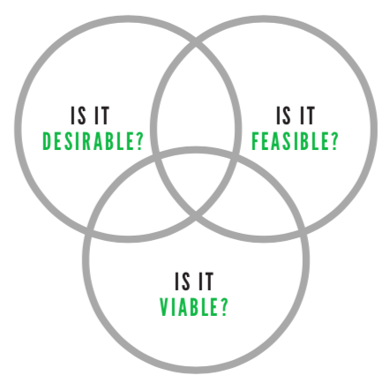
Is micro-housing desirable for homeless veterans? What micro-housing options are feasible? Is this project viable? Through our research, we found that this is something that homeless veterans want. Micro-housing may be desirable only to some subgroups, but the need for security and safety was universal for our interview subjects. Now, you are tasked with finding what is feasible and what is viable. Feasibility is all about design. Can you design micro-housing units that make the veterans living there feel proud, safe, and comfortable? With the help of Professor Allebaugh and others involved in this project, we hope that we can viably house homeless veterans.

